A

Project Report on

**DERMATOLOGICAL DISORDER DETECTION USING CNN**

*Submitted in partial fulfilment of the requirements*

*for the award of the degree of*

**BACHELOR OF TECHNOLOGY**

**In**

**COMPUTER SCIENCE AND ENGINEERING**

*Submitted by*

**V MOHAMMAD YASEEN 19AK1A05D2**

**V YASASWINI DURGA 19AK1A05I8**

**V SAI GNAPIKA 19AK1A05D8**

**K VISHNUCHANDANRAO 19AK1A05I6**

**Under the Guidance of**

**Dr. K. NAVAZ., M.E., Ph.D.**

**Professor, Dept Of CSE**



**COMPUTER SCIENCE AND ENGINEERING**

## **ANNAMACHARYA INSTITUTE OF TECHNOLOGY AND SCIENCES (AUTONOMOUS)**

(Approved by AICTE, New Delhi & Permanent Affiliation to JNTUA, Anantapur.

Three B. Tech Programmes (CSE, ECE & CE) are accredited by NBA, New Delhi, Accredited by NAAC with ‘A’ Grade , Bangalore. Accredited by Institution of Engineers (India), KOLKATA. A-grade awarded by AP Knowledge Mission. Recognized under sections 2(f) & 12(B) of UGC Act 1956.)Tirupati-517520.

2019-2023

## **ANNAMACHARYA INSTITUTE OF TECHNOLOGY AND SCIENCES (AUTONOMOUS)**

(Approved by AICTE, New Delhi & Permanent Affiliation to JNTUA, Anantapur.

Three B. Tech Programmes (CSE, ECE & CE) are accredited by NBA, New Delhi, Accredited by NAAC with ‘A’ Grade , Bangalore. Accredited by Institution of Engineers (India), KOLKATA. A-grade awarded by AP Knowledge Mission. Recognized under sections 2(f) & 12(B) of UGC Act 1956.)Tirupati-517520.

2019-2023

**COMPUTER SCIENCE AND ENGINEERING**



# **CERTIFICATE**

*Certified that this is a bonafide record of the Project Report entitled,* ***“DERMATOLOGY DISORDER DETECTION USING CNN”,*** *done by* **V MOHAMMAD YASEEN (19AK1A05D2),** **V YASASWINI DURGA (19AK1A05I8), V SAIGNAPIKA (19AK1A05D8),** **K VISHNUCHANDANRAO (19AK1A05I6)** *is being submitted in partial fulfilment of the requirements for the award of the degree of* ***BACHELOR OF TECHNOLOGY*** *in* ***COMPUTER SCIENCE AND******ENGINEERING*** *to the Annamacharya Institute of technology and Sciences, Tirupati, during the academic year 2022-23.*

|  |  |
| --- | --- |
| Signature of the supervisor  **Dr. K. NAVAZ., M.E., Ph.D.**  Professor,  Department of CSE,  AITS, Tirupati | Signature of Head of the Department  **Mr. B. RAMANA REDDY., MTech (Ph.D).)**  Associate professor and HOD,  Department of CSE,  AITS, Tirupati |

**DATE:**

**INTERNAL EXAMINER** **EXTERNAL EXAMINER**

## **ANNAMACHARYA INSTITUTE OF TECHNOLOGY AND SCIENCES (AUTONOMOUS)**

(Approved by AICTE, New Delhi & Permanent Affiliation to JNTUA, Anantapur.

Three B. Tech Programmes (CSE, ECE & CE) are accredited by NBA, New Delhi, Accredited by NAAC with ‘A’ Grade , Bangalore. Accredited by Institution of Engineers (India), KOLKATA. A-grade awarded by AP Knowledge Mission. Recognized under sections 2(f) & 12(B) of UGC Act 1956.)Tirupati-517520.

2019-2023

**COMPUTER SCIENCE AND ENGINEERING**



# **DECLARATION**

We hereby declare that the project titled **“DERMATOLOGICAL DISORDER DETECTION USING CNN”** is a genuine project work carried out by us, in **B.Tech (Computer Science and Engineering)** course in **Annamacharya Institute of Technology And Sciences, Tirupati** and has not been submitted to any other course or university for the award of our degree by us.

**V MOHAMMAD YASEEN 19AK1A05D2**

**V YASASWINI DURGA 19AK1A05I8**

**V SAI GNAPIKA 19AK1A05D8**

**K VISHNUCHANDANRAO 19AK1A05I6**

**ACKNOWLEDGEMENT**

The satisfaction that accompanies the successful completion of the task would be put incomplete without the mention of the people who made it possible, whose constant guidance and encouragement crown all the efforts with success.

We avail this opportunity to express our deep sense of gratitude and hearty thanks to  **Dr.** **C. GANGI REDDY,** Hon’ble Secretary of AITS-Tirupati, for providing congenial atmosphere and encouragement.

We show gratitude to **Dr. C. NADHAMUNI REDDY**, **Principal** for having provided all the facilities and support.

We would like to thank **Mr. B. RAMANA REDDY., M.Tech,(Ph.D), Associate professor & HOD**, **Computer Science and Engineering** for encouragement at various levels of our Project.

We thankful to our project coordinator **Mr. V. SAMBASIVA, Assistant Professor, CSE,** for his sustained inspiring guidance and cooperation throughout the process of this project.

We would like to express our sincere gratitude to our supervisor **Dr. K. NAVAZ, Professor**, Dept. of CSE, AITS, for his constant help, kind cooperation and encouragement in completing the work successfully.

We express our deep sense of gratitude and thanks to all the **Teaching** and **Non-Teaching Staff** of our college who stood with us during the project and helped us to make it a successful venture.

We place highest regards to our **Parents**, **Friends** and **Well wishers** who helped a lot in making the report of this project.

**V MOHAMMAD YASEEN 19AK1A05D2**

**V YASASWINI DURGA 19AK1A05I8**

**V SAI GNAPIKA 19AK1A05D8**

**K VISHNUCHANDANRAO 19AK1A05I6**

**CONTENTS**

**CHAPTER NO NAME OF THE CHAPTER PAGE NO**

Abstract i

List of figures ii

List of screens iii

List of abbreviations iv

**Chapter 1 INTRODUCTION**

* 1. Introduction 1
  2. Review Of Literature 2
  3. Existing System 5
  4. Disadvantages of Existing System 6
  5. Proposed System 7
  6. Advantages of Proposed System 8

**Chapter 2 ANALYSIS**

**2.1** Introduction 9

**2.1.1** Analysis Model 9

**2.2** Feasability Study 13

**2.3** Software Requirements specification 14

**2.2.1** User Requirements 14

**2.2.2** Software Requirements 16

**2.2.3**  Hardware Requirements 16

**2.4** Modules & Libraries 16

**2.5** Flowchart 18

**2.5.1** ML Model FlowChart 18

**2.5.2** WebPage FlowChart 19

**2.6** Methadology & Description 20

**Chapter 3**  **DESIGN**

**3.1** Introduction 25

**3.2**  DFD/UML Diagrams 26

**3.3** Software Development Life Cycle-SDLC 35

**CHAPTER NO NAME OF THE CHAPTER PAGE NO**

**Chapter 4 IMPLEMENTATION & DETAILS**

**4.1** Introduction 37

**4.1.1** How Skin Disease Classifier Work?38

**4.2** Explanation of Key Functions 39

**4.3** Method of Implementation 40

**4.3.1** The Project Is Implemented As Python 40

**4.3.2** Modules 45

**4.4** Algorithm 43

**4.4.1** Convolutional Neural Network 43

**4.5** SampleCode & Output Screens 48

**4.5.1** SampleCode 48

**4.5.2** Output Screens 51

**Chapter 5 TESTING & VALIDATION**

**5.1** Introduction 57

**5.2** Design of test cases & scenarios 59

**5.3** Validation 63

**Chapter 6 CONCLUSION & FUTURE ENHANCEMENT**

**6.1** Conclusion 64

**6.2** Future Enhancement 64

**Chapter 7 BIBILOGRAPHY** 65

**APPENDIX A**

|  |  |
| --- | --- |
| **S.No** | **PUBLICATIONS** |
| **1** | International Conference Certificates |
| **2** | Journal Paper |
| **3** | Journal Certificates |

**ABSTRACT**

Dermatological diseases are found to induce a serious impact on the health of millions of people as everyone is affected by almost all types of skin disorders every year. Since the human analysis of such diseases takes some time and effort, and current methods are only used to analyse singular types of skin diseases, there is a need for a more high-level computer-aided expertise in the analysis and diagnosis of multi-type skin diseases. It is necessary to develop automatic methods in order to increase the accuracy of diagnosis for multi type skin diseases.Living creature skin disease is a fairly prevalent ailment. In the medical world, monitoring dermatological disorders and classifying them is a complex process. Due to the sheer intricacy of individual skin tone and the visible proximity effect of infections, recognizing the precise type can be challenging at times. As a result, it is critical to diagnose and recognize skin disease as soon as possible. Artificial intelligence (AI) is quickly expanding in therapeutic areas in a modern context. For diagnostic purposes, much deep learning (DL) and machine learning (ML) methods are applied. These strategies drastically enhance the diagnosing process while also speeding it up. In this study, to improve disease detection, a model combining deep learning (DL) and machine learning (ML) has been developed. For classification, three sets of machine learning models were utilized, while Support Vector Machine, Decision tree, and Ensemble boosting Adaboost classifier were applied for classification. To identify the best prediction model, a comparative study was carried out. The hybrid method Resnet50 with SVM produced the best results, with 99.11% accuracy.

We proposed an image processing-based method to detect skin diseases. This method takes the digital image of disease effect skin area, and then uses image analysis to identify the type of disease. Our proposed approach is simple, fast and does not require expensive equipment, it can run on any device which has internet access. Just upload the image of your skin and check whether you have any skin disease or not.

**LIST OF FIGURES**

**Fig No Name Page No**

2.1 SDLC Spiral Model 10

2.2 Spiral Model 12

2.3 Flow Chart Of ML Model 18

2.4 Flow Chart Of Web Page 19

2.5 Proposed Framework Flow Chart 20

2.6 Proposed CNN Architect For Skin Lesiom Segmentation 21

2.7 Proposed Framework Segmentation Results 22

3.1 DFD Symbols 27

3.2 Level-0 DFD 28

3.3 Level-1 DFD 28

3.4 Use Case Diagram 30

3.5 Sequence Diagram 31

3.6 Activity Diagram 32

3.7 Class Diagram 33

3.8 Component Diagram 35

3.9 Water Fall Model 35

4.1 Convolutional Neural Network 44

4.2 Sample 3 x 3 filter 45

4.3 Applying the filter 46

4.4 CNN Architecture 46

**LIST OF SCREENS**

**Screen No Name Page No**

4.1 Home Screen 51

4.2 Choosing Image From Acne Dataset 52

4.3 Predicting Image As Acne 52

4.4 Choosing Image From Melanoma Dataset 53

4.5 Predicting Image As Melanoma 53

4.6 Choosing Image From Rosacea Dataset 54

4.7 Predicting Image As Rosacea 54

4.8 Choosing Image From Vitiligo Dataset 55

4.9 Predicting Image As Vitiligo 55

4.10 User.py Output 56

4.11 Admin.py Output 56

**LIST OF ABBRERVIATIONS**

**SHORT FORM ABBREVIATION**

AI Artificial intelligence

ML Machine Learning

DL Deep Learning

SVM Support Vector Machine

ResNet Residual Neural Networks

CNN Convolutional Neural Networks

STD Sexually Transmitted Diseases

ORB Oriented FAST and Rotated BRIEF

RANSAC RANdom Sample Consensus

BRS Business Requirement Specifications

SRS System Requirement Specifications

SDLC Software Development Life Cycle

HTML Hypertext Markup Language

CSS Cascading Style Sheet  
RAM Random Access Memory

PIL Python Imaging Library

ITK Insight Segmentation and Registration Toolkit

IWC International Whaling Commission

GLCM Gray-Level Co-Occurance Matrix

ROC Receiver Operating Characteristic

DFD Data Flow Diagram

UML Unified Modelling Language

DLL Dynamic Link Library

RELU Rectified linear activation function

ANN Artificial Neural Network

DBN Deep belief network

DNN Deep neural network

PCA Principal component analysis

**1. INTRODUCTION**

**1.1 INTRODUCTION**

Skin diseases are one of the most common medical conditions affecting people worldwide. They can range from mild irritations to chronic conditions that significantly affect a person's quality of life. Early detection and prompt treatment of skin diseases are crucial to prevent complications and ensure better outcomes. One of the recent advancements in medical technology is the development of skin disease prediction systems that use artificial intelligence and machine learning algorithms to predict the risk of developing skin diseases. Skin disease prediction systems rely on various factors, including age, gender, family history, lifestyle habits, and environmental factors, to determine the likelihood of developing a particular skin condition. These systems are designed to be user-friendly, and users can input their information and receive personalized predictions of their risk of developing skin diseases. The accuracy of these predictions is continually improving as the systems are fed more data and undergo constant refinement. The benefits of skin disease prediction systems are numerous. By accurately predicting the risk of developing a particular skin condition, people can take proactive measures to prevent or mitigate the effects of the disease. For instance, if a person is predicted to be at high risk of developing skin cancer, they can take steps to protect themselves from excessive sun exposure and get regular skin checkups. Additionally, these systems can also help medical professionals provide better care by allowing for early detection and targeted treatment. Skin diseases are more common than other diseases. Skin diseases may be caused by fungal infection, bacteria, allergy, or viruses, etc. A skin disease may change texture or color of the skin. In general, skin diseases are chronic, infectious and sometimes may develop into skin cancer. Therefore, skin diseases must be diagnosed early to reduce their development and spread. The diagnosis and treatment of a skin disease takes longer time and causes financial and physical cost to the patient. In general, most of the common people do not know the type and stage of a skin disease. Some of the skin diseases show symptoms several months later, causing the disease to develop and grow further. This is due to the lack of medical knowledge in the public. Sometimes, a dermatologist (skin specialist doctor) may also find it difficult to diagnose the skin disease and may require expensive laboratory tests to correctly identify the type and stage of the skin disease.Thus,the computer based diagnosis of skin diseases comes into place to produce the result within a short interval of time with more accuracy than human analysis using laboratory methods.

In conclusion, skin disease prediction systems are a promising technology that can improve early detection and management of skin diseases. By using artificial intelligence and machine learning algorithms to predict the risk of developing skin conditions, these systems can help people take proactive measures to prevent or mitigate the effects of these diseases. With further research and development, skin disease prediction systems can potentially revolutionize the way we diagnose and manage skin diseases, leading to better outcomes and quality of life for those affected.

**1.2 REVIEW OF LITERATURE**

1. **TITLE:** **Skin Diseases Prediction using Deep Learning Framework.**

**Author:** Padmavathi S, Mathu Mithaa E, Kiruthika T, Ruba M.

**Year:** 2020.

**Abstract:**

Dermatological diseases are found to induce a serious impact on the health of millions of people as everyone is affected by almost all types of skin disorders every year. Since the human analysis of such diseases takes some time and effort, and current methods are only used to analyse singular types of skin diseases, there is a need for a more high-level computer-aided expertise in the analysis and diagnosis of multi-type skin diseases. This paper proposes an approach to use computer-aided techniques in deep learning neural networks such as Convolutional neural networks (CNN) and Residual Neural Networks (ResNet) to predict skin diseases real-time and thus provides more accuracy than other neural networks.

Since the human analysis of skin diseases takes some time and effort, and current methods are only used to analyse singular types of skin diseases, there is a need for a more high-level computer-aided expertise in the analysis and diagnosis of multi-type skin diseases. By using the appropriate methods the dataset is studied and then by applying various techniques andalgorithms the skin disease can be predicted. Comparison among algorithms helps to achieve the best one which provides high accuracy.

1. **TITLE:** **Skin Disease Detection Using Computer Vision And Machine Learning Technique.**

**Author:** Leelavathy S, Jaichandran R, Shobana R, Vasudevan, Sreejith S Prasad and Nihad.

**Year:** 2020.

**Abstract:**

Skin types of diseases are most common among the globe, as people get skin disease due to inheritance, environmental factors. In many cases people ignore the impact of skin disease at the early stage. In the existing system, the skin disease is identified using biopsy process which is analyzed and medicinal prescribed manually by the physicians. To overcome this manual inspection and provide promising results in short period of time, we propose a hybrid approach combining computer vision and machine learning techniques. For this the input images would be microscopic images i.e. histopathological from which features like color, shape and texture are extracted and given to convolutional neural network (CNN) for classification and disease identification. Our objective of the project is to detect the type of skin disease easily with accuracy and recommend the best and global medical suggestions.

1. **TITLE:** **Skin Disease Detection Using Deep Learning.**

**Author:** Sruthi Chintalapudi, Vikas Prateek Mishra, Shubham Sharma, Sunil Kumar.

**Year:** 2021.

**Abstract:**

The image categorization is a classical problem of image processing, computer vision, and machine learning fields. In this paper, we will see the image classification using deep learning. This paper gives a way to deal with utilize different PC vision-based strategies (profound figuring out how) to naturally anticipate the different sorts of skin infections. In the developed application, the user will be provided with a portal where they can upload images and they will be checked for most common skin diseases (including STDs) by an algorithm developed using deep learning by training it with a vast variety of images. This technique takes the digital image of disease as input of affected skin area, then uses image analysis to identify the type of disease. This methodology thinks of basic, quick, and doesn't need costly hardware other than a camera and a computer. The methodology works on the inputs of a color image. At that point resize the picture to extricate highlights utilizing convolutional neural organization. Finally, the outcomes appear to the client, including the sort of sickness, spread, and seriousness.

1. **TITLE**: **Skin Disease Detection System Technologies Using Image Processing and Deep Learning.**

**Author:** Sakshi Yadav, Samraddhi Singh , Akshay Tiwari, Nandani Sharma.

**Year:** 2022.

**Abstract:**

Skin Disorders are one of the diseases that are widely spread around the world that can occur in people of all ages. Their diagnosis has been made possible with the help of advanced medical technologies. The cost of such

diagnosis is very limited and expensive which makes it impossible for people those who cannot spend high fees for their treatment. This paper has been proposed due to the lack of medical facilities and high-cost requirement for the treatment, the patients may need to wait which in turn may increases the severity/infection of the disease so to avoid this their early detection is must. This paper presents a skin disease detection system using image processing and deep learning. This system is accessible even in remote areas where dermatologists are limited or not available. The system is very easy to use, the only thing the patient has to do is to upload the picture of the infected area of the skin as an input to the prototype. The proposed system consists of three phases- feature detection, feature extraction and the feature match (comparison with database). Initially, the skin image is processed to detect it’s inliers and outliers features and then it’s description using ORB (Oriented FAST and Rotated BRIEF) and RANSAC (RANdom Sample Consensus). Finally, by using BRUTEFORCE HAMMING method, the matching of image features is performed, identifies the disease and displays the result. Here deep learning method is used to train the system with various skin disease images and then helps in classification of skin diseases. Our approach is very simple, fast and do not require any expensive technology other than camera and computer.

**1.3 EXISTING SYSTEM**

There are several existing systems for skin disease prediction that have been developed over the years. These systems use various technologies, including artificial intelligence and machine learning algorithms, to predict the risk of developing skin diseases. One of the most popular systems is the Dermatology AI, which uses a convolutional neural network to diagnose skin diseases based on images of skin lesions. Another existing system is the SkinVision app, which allows users to take photos of their skin and receive personalized risk assessments for various skin conditions. The app uses a machine learning algorithm to analyze the images and provide a risk score for skin cancer. There are also several other systems that focus on specific skin conditions, such as the Psoriasis Prediction Tool, which uses a machine learning algorithm to predict the likelihood of developing psoriasis based on genetic factors and environmental exposures. While these existing systems have shown promising results, they are still in the early stages of development and require further refinement to improve accuracy and reliability. Additionally, there are still limitations to these systems, such as the need for high-quality images for accurate diagnosis and the potential for bias in the algorithms based on the data used to train them.

Overall, the existing systems for skin disease prediction represent a significant advancement in medical technology and have the potential to revolutionize the way we diagnose and manage skin diseases. With further research and development, these systems can potentially improve the accuracy and reliability of skin disease diagnosis, leading to better outcomes and quality of life for those affected.

**1.4 DISADVANTAGES OF EXISTING SYSTEM**

While skin disease prediction systems represent a significant advancement in medical technology, there are still some disadvantages to these systems. One of the major limitations is the potential for bias in the algorithms used to predict skin diseases. This bias can be due to various factors, including the quality and quantity of the data used to train the algorithms, which can lead to inaccurate or incomplete predictions. Another disadvantage of these systems is the need for high-quality images for accurate diagnosis. The accuracy of the diagnosis is heavily dependent on the quality of the images, which can be challenging to obtain in some cases. Additionally, these systems may not be able to diagnose skin conditions that do not present with typical symptoms or may be difficult to identify. Another significant limitation of existing skin disease prediction systems is the lack of regulation and standardization in the industry. With so many different systems available, there is a risk of misdiagnosis or incorrect treatment recommendations, which can have serious consequences for patients. Finally, another disadvantage of these systems is the potential for over-reliance on technology, which can lead to the neglect of other important aspects of patient care, such as the physical examination and history-taking. It is essential to ensure that these systems are used as a tool to aid in diagnosis and treatment rather than as a substitute for clinical judgment.

In conclusion, while existing skin disease prediction systems represent a significant advancement in medical technology, there are still some disadvantages and limitations to these systems. To overcome these limitations, it is important to ensure that these systems are thoroughly tested and regulated, and that they are used as a tool to aid in diagnosis and treatment rather than as a substitute for clinical judgment.

**1.5 PROPOSED SYSTEM**

A proposed system for skin disease prediction is one that combines artificial intelligence and human expertise to improve accuracy and reliability. The system would use machine learning algorithms to analyze patient data and medical images and provide a preliminary diagnosis of the skin condition. The system would then refer the diagnosis to a dermatologist for review and confirmation. The proposed system would use a variety of data sources to make accurate predictions, including patient history, lifestyle habits, genetic factors, and environmental factors. This would allow for a more personalized and precise diagnosis, leading to better outcomes for patients. Another key feature of the proposed system is the inclusion of a dermatologist's review of the diagnosis. This would ensure that the diagnosis is accurate and reliable, reducing the risk of misdiagnosis or incorrect treatment recommendations. Additionally, the dermatologist's expertise can provide valuable insights into the patient's condition and guide treatment decisions. The proposed system would also be subject to strict regulation and standardization to ensure that it meets high standards of accuracy, reliability, and patient safety. This would involve ongoing testing and refinement of the algorithms used to make predictions, as well as strict protocols for data collection and analysis.

Overall, the proposed system for skin disease prediction represents a significant advancement in medical technology and has the potential to improve accuracy and reliability in diagnosis and treatment. By combining artificial intelligence and human expertise, this system can provide more personalized and precise diagnoses, leading to better outcomes and quality of life for patients.

**1.6 ADVANTAGES OF PROPOSED SYSTEM**

The proposed system for skin disease prediction offers several advantages over existing systems. One of the key advantages is the integration of artificial intelligence and human expertise, which can improve accuracy and reliability in diagnosis and treatment. By combining machine learning algorithms with a dermatologist's review of the diagnosis, the system can provide more personalized and precise diagnoses, leading to better outcomes for patients. Another advantage of the proposed system is the use of a variety of data sources to make accurate predictions. By taking into account patient history, lifestyle habits, genetic factors, and environmental factors, the system can provide a more comprehensive analysis of the patient's condition, leading to more accurate and effective treatment. The proposed system also offers the advantage of being subject to strict regulation and standardization, ensuring that it meets high standards of accuracy, reliability, and patient safety. This would involve ongoing testing and refinement of the algorithms used to make predictions, as well as strict protocols for data collection and analysis. Additionally, the proposed system can potentially reduce healthcare costs by providing earlier and more accurate diagnoses, leading to more timely and effective treatment. By improving the accuracy of diagnoses, the system can also reduce the need for unnecessary tests and procedures, leading to cost savings for patients and healthcare providers.

Overall, the proposed system for skin disease prediction represents a significant advancement in medical technology and has the potential to improve accuracy and reliability in diagnosis and treatment, leading to better outcomes and quality of life for patients, while also potentially reducing healthcare costs.

**2. ANALYSIS**

**2.1 INTRODUCTION**

Skin disease detection can be performed through various methods including visual inspection, biopsy, and laboratory tests. However, in recent years, machine learning algorithms and computer vision techniques have been employed for the automatic detection of skin diseases. The first step in skin disease detection is the acquisition of images of the affected area. This can be done using various techniques such as dermoscopy, digital photography, and confocal microscopy. These images are then preprocessed to remove noise, adjust lighting, and enhance the contrast. Once the preprocessed images are available, a feature extraction process is performed to identify relevant features that can be used for classification. This can be done using various techniques such as texture analysis, color analysis, and morphological analysis. The extracted features are then fed into a machine learning algorithm such as a decision tree, support vector machine, or deep neural network to classify the image into one of several possible categories of skin diseases. To train the machine learning algorithm, a large dataset of skin disease images with corresponding labels is required. This dataset should be diverse and representative of the different types of skin diseases. The accuracy of the algorithm can be improved by incorporating additional information such as patient history, age, and gender.

Overall, machine learning algorithms and computer vision techniques show promise for the automatic detection of skin diseases. However, further research is required to optimize the performance of these algorithms and to ensure their reliability in clinical settings.

**2.1.1 Analysis Model**

The model that is basically being followed is the SPIRAL MODEL, which states that the phases are organized in a linear order. First of all, the feasibility study is done. Once that part is over the requirement analysis and project planning begins. If the system exists one and modification and addition of new module is needed, analysis of present system can be used as basic model.

The design starts after the requirement analysis is complete and the coding begins after the design is complete. Once the programming is completed, the testing is done. In this model the sequence of activities performed in a software development project are

• Requirement Analysis

• Project Planning

• System Design

• Coding

• Unit Testing

The spiral model combines the idea of iterative development with the systematic, controlled aspects of the waterfall model. This Spiral model is a combination of iterative development process model and sequential linear development model i.e. the waterfall model with a very high emphasis on risk analysis. It allows incremental releases of the product or incremental refinement through each iteration around the spiral.

To explain in simpler terms, the steps involved in spiral model are:

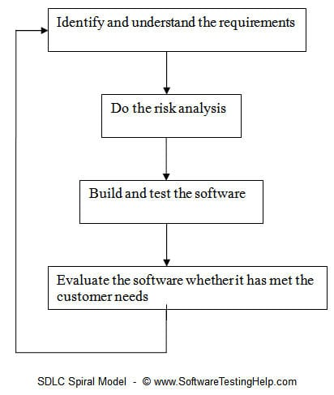

**Fig 2.1: SDLC Spiral Model**

**Spiral Model-Design:**

The spiral model has four phases. A software project repeatedly passes through these phases in iterations called Spirals.

**Identification:**

This phase starts with gathering the business requirements in the baseline spiral. In the subsequent spirals as the product matures, identification of system requirements, subsystem requirements and unit requirements are all done in this phase.

This phase also includes understanding the system requirements by continuous communication between the customer and the system analyst. At the end of the spiral, the product is deployed in the identified market. This identification and/or planning phase also includes understanding the system requirements by continuous communication between the customer and the system analyst team members. Requirements like Business Requirement Specifications (BRS) and System Requirement specifications (SRS). At the end of the spiral the product is deployed in the identified market.

**Design:**

The Design phase starts with the conceptual design in the baseline spiral and involves architectural design, logical design of modules, physical product design and the final design in the subsequent spirals. Design phase is also known as evaluation phase of SDLC spiral model. This phase starts with the conceptual design in the baseline spiral and involves architectural design, logical design of modules, physical product design and final design in the subsequent spirals. The main agenda of this phase is to allow the customer to evaluate the output of the project to data before the project continues to the next spiral.

These four phases of spiral model cover in a single iteration process. For the next iteration the customer evaluation, software development process is entering and subsequently follows the linear approach to implement the feedback suggested by the customer. The process of iterations along with the spiral model continues throughout the life of developed software.

**software.Construct or Build:**

This phase refers to the actual production of the software product at every spiral or iteration process. This phase of spiral model has software development along with testing of product before launching. In the baseline spiral when the product is just thought of and the design is being developed a POC (Proof of Concept) is developed in construct or build phase by the designed expertise to get customer feedback.

Then in the subsequent spirals with higher clarity on requirements and design details a working model of the software called build is produced with a version number. These builds are sent to the customer for feedback.

**Evaluation and Risk Analysis:**

Risk Analysis includes identifying, estimating and monitoring the technical feasibility and management risks, such as schedule slippage and cost overrun. After testing the build, at the end of first iteration, the customer evaluates the software and provides feedback.

In this phase also includes of risk analysis a process is undertaken to identify risk in the product and to handle that risk development team have alternate solutions. At the end of this phase a prototype is produced that works as an alternate solution are suggested and implemented if an unwanted risk found during the risk analysis phase.

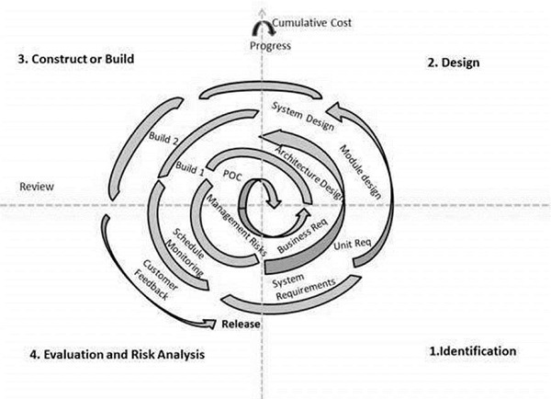The following illustration is a representation of the Spiral Model, listing the activities in each phase.

**Fig 2.2: Spiral Model**

Based on the customer evaluation, the software development process enters the next iteration and subsequently follows the linear approach to implement the feedback suggested by the customer. The process of iterations along the spiral continues throughout the life of the software.

**Application of SDLC spiral model:**

Various software application development models available in market those are used by the software industries. Each software development application has different requirements based on internal and external factors. Similar for the spiral model, this modeling approach is very widely used in the software industry as it is in sync with the natural development process of any product i.e. learning with maturity and also involves minimum risk for the customer as well as the development firms. Following are the typical uses of Spiral model:

* Requirements are complex and need evaluation to get clarity.
* New product line which should be released in phases to get enough customer feedback.
* When costs there are a budget constraint and risk evaluation is important.
* Long-term project commitment because of potential changes to economic priorities as the requirements change with time.
* For medium to high-risk projects development.
* Customer is not sure of their requirements which are usually the case.
* Significant changes are expected in the product during the development cycle.

**2.2 FEASABILITY STUDY**

The feasibility of the project is analyzed in this phase i.e., the project is feasible for supporting with unlimited resources and infinite time. In feasibility the business proposal is put forth with a very general plan for the project and some cost estimates. During system analysis the Feasibility study of the proposed system is to be carried out. This is to ensure that the proposed system is not a burden to the company.

When the system authority or any other person makes a request, the first system activity i.e. the preliminary analysis begins. An important outcome of the preliminary analysis is the determination that the system request is feasible.

Feasibility study is a compressed capsule version of scope and an objective is confirmed and corrected any constraints imposed on the system are identified. Heuristics are searched as analysis for feasibility.

For feasibility analysis, some understanding of the major requirements for the system is essential.

• Economic feasibility

• Technical feasibility

• Operational feasibility

**2.2.1 Economical Feasibility:**

The burdens can easily be reduced when the searching/ browsing of keyword search result is fast. So, one can say that a product is economically feasible. Users can easily able to find the top files in the cloud server. The search processing which is implemented in this system is fast when compared to other systems.

**2.2.2 Technical Feasibility:**

Technical feasibility centers on the existing computer system (hardware, software, etc.,) and to what extent it can support the proposed addition. If the budget is a serious constraint, then the project is judged not feasible. Technical feasibility speaks about the existing hardware and the software.

**2.2.3 Operational Feasibility:**

This system is very user friendly any user can be able to work with the system without any instructions to them. This system which contains the good GUI with atheistically pleasing colors.

**2.3 SOFTWARE REQUIREMENTS SPECIFICATION**

**2.3.1 User Requirements**

* PC, Mac or laptop with x86-64 (64-bit) compatible processors.
  + 2 GHz or better processor is recommended.
  + [AVX2](https://en.wikipedia.org/wiki/Advanced_Vector_Extensions#Advanced_Vector_Extensions_2) support is highly recommended. Processors that do not support AVX2 will still run Neurotechnology Image Processing algorithm, but in a mode, which will not provide the specified performance. Most modern processors support this instruction set, but please check if a particular processor model supports it.
* At least 512 MB of free RAM should be available for the application.
* Internet connection required for managing the Image Processing Validation.
* Microsoft Windows specific requirements:
  + Microsoft Windows 7 / 8 / 10 / 11.
  + One of following development environments for application development:
    - Python IDLE
    - Jupiter Notebook
* macOS specific requirements:
  + macOS 10.13 or newer.
  + XCode 9.3 or newer (for application development)
  + GStreamer 1.10.x or newer with gst-plugin-base and gst-plugin-good is required for Image Processing using CNN (for application development)
  + GNU Make 3.81 or newer (to build samples and tutorials development)
  + Anaconda
* Linux specific requirements:
  + Linux 3.10 kernel or newer
  + glibc 2.17 library or newer
  + GStreamer 1.10.x or newer with gst-plugin-base and gst-plugin-good is required for Image Processing using CNN
  + gcc 4.8 or newer (for application development)
  + GNU Make 3.81 or newer (for application development)
  + Anaconda
* Need for an application that makes communicating easy and comfortable.
* An application that enables user to predict the skin disease with image.
* Need for an application that is easy to use and widely available and hence a web application
* Handling all functions done with organization in a computerized manner.
* Allowing the user to predict skin disease easily.

**2.3.2 Software Requirements**

* Operating System – Windows 10
* Front End – HTML,CSS
* Back End – Python
* Framework –Flask

**2.3.3: Hardware Components**

* Processor – i3 or above.
* Hard Disk – 2 GB
* Memory – 8 GB RAM

**2.4 MODULES & LIBRARIES**

* + - **OpenCV** is an open-source library that was developed by Intel in the year 2000. It is mostly used in computer vision tasks such as object detection, face detection, face recognition, image segmentation, etc but also contains a lot of useful functions that you may need in ML.
    - **scikit-image** is a python-based image processing library that has some parts written in Cython (Cython is a programming language which is a superset of Python programming language designed to have performance like C programming language.) to achieve good performance.

It includes algorithms for:

* + - Segmentation,
    - Geometric transformations,
    - Color space manipulation,
    - Analysis,
    - Filtering,
    - Morphology,
    - Feature detection, and more
    - You will find it useful for pretty much any computer vision task.
    - The scikit-image uses NumPy arrays as image objects.
* **Scipy** is used for mathematical and scientific computations but can also perform multi-dimensional image processing using the submodule scipy.ndimage. It provides functions to operate on n-dimensional Numpy arrays and at the end of the day images are just that.

Scipy offers the most commonly used image processing operations like:

* Reading Images
* Image Segmentation
* Convolution
* Face Detection
* Feature Extraction and so on.
* **PIL** (Python Imaging Library) is an open-source library for image processing tasks that requires python programming language. PIL can perform tasks on an image such as reading, rescaling, saving in different image formats.
* PIL can be used for Image archives, Image processing, Image display.
* **Numpy** An image is essentially an array of pixel values where each pixel is represented by 1 (greyscale) or 3 (RGB) values. Therefore, NumPy can easily perform tasks such as image cropping, masking, or manipulation of pixel values.
* **ITK** or Insight Segmentation and Registration Toolkit is an open-source platform that is widely used for Image Segmentation and Image Registration (a process that overlays two or more images).
* **Pgmagick** is a GraphicsMagick binding for Python that provides utilities to perform on images such as resizing, rotation, sharpening, gradient images, drawing text, etc.
* **Python IDE:** There are lots of IDEs for python. Some of them are PyCharm, Thonny, Ninja, Spyder, anaconda etc. Ninja and Spyder both are very excellent and free but we used Spyder as it feature- rich than ninja. Anaconda is used for our present system.

**2.5 FLOWCHART**

**2.5.1 ML Model FlowChart**

Our proposed model consists of three major stages:

1. **Input data preprocessing:** This step is focused on structuring the input data so that our model can handle it easily.

2. **Processing:** This step involves utilizing IWC to organize input data into categories and creating a Decision Tree for categorization.

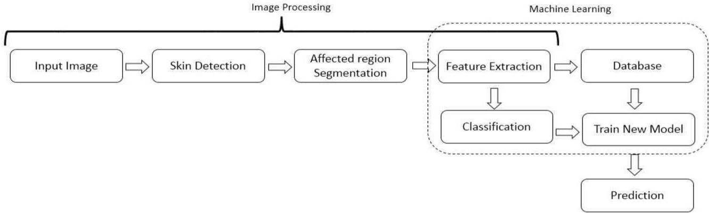3. **Predictions:** This step is about making predictions using the Decision Tree that has previously been constructed. From then, the decision tree model will determine the extent to which the picture fits the database in terms of predicted percentage. Clustering is done based on the similarity of data characteristics. The preprocessed input data is divided into two groups after clustering: one for training and constructing the decision tree, and the other for evaluating the decision tree’s accuracy in discriminating between all nine illnesses.

**Fig 2.3: Flow Chart Of ML Model**

**2.5.2 WebPage FlowChart**

Here is a flowchart of a basic decision-making process using the flowchart theory:

**Define the problem:** Identify the problem or decision that needs to be made.

**Gather information:** Collect all relevant information that pertains to the problem or decision.

**Identify the decision criteria:** Determine the criteria that will be used to evaluate possible solutions to the problem.

**Generate alternatives:** Develop a list of possible solutions or courses of action.

**Evaluate alternatives:** Evaluate each alternative against the decision criteria.

**Choose the best alternative:** Select the alternative that best meets the decision criteria.

**Implement the decision:** Put the chosen alternative into action.

**Monitor and evaluate the decision:** Continuously monitor and evaluate the decision to ensure that it is achieving the desired outcomes and adjust as necessary.

**Iterate:** If the decision is not working as desired, repeat the decision-making process by going back to step 1 and adjusting the problem definition, information gathering, decision criteria, or alternative generation as needed.

**USER**

**MAIN PAGE**

**UPLOAD THE IMAGE OF THE EFFECTIVE AREA OF THE SKIN OF THE USER**

**RESULT PAGE**

**Fig 2.4: Flowchart Of WebPage**

**2.6 METHADOLOGY & DESCRIPTION**

**2.6.1 Data Normalization**

Data augmentation techniques were used to resize collected images because the dataset collected from two databases with images contain different sizes for different types of diseases. In this process, Eq. (1). is used to resize the images. MSE = 1 mn m, n i, j=0 I(i, j)K(i, j) (1) The calculated MSE value is further passed to the PSNR value, where all operations are performed using the nearest neighbor interpolation method.

**2.6.2 Semantic Segmentation Using CNN**

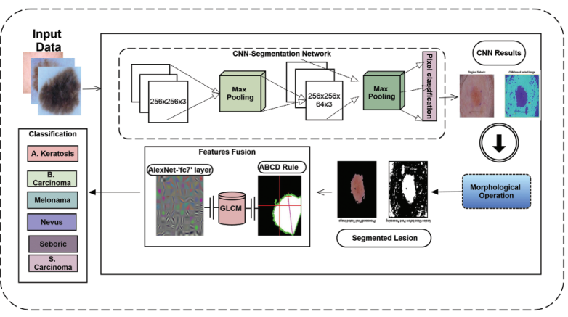In the proposed technique, segmentation is performed for the background and lesion areas using a CNN model. The size of the input is crucial because it forms the basic structure of CNN. The image 256 × 256 × 3 with “zero centers” normalization input size is given to the input layer of the CNN. The convolution layer of CNN takes images from the input layer and applies 64 filters with sizes based on 3 × 3, [1 1] convolution stride, and [1 1 1 1] padding on the selected images.

**Fig 2.5: Proposed framework flowchart**

The ReLU activation function is used as a decision-making function on the convolution layer. Following that, size 2 × 2 max pooling is performed using [2 2] stride and [0 0 0 0] padding. Then, with the same customization, two more convolutional blocks are added. Finally, two fully connected layers are introduced: one is a pixel classification layer, and the other is a SoftMax layer, which is performed after three convolution layers. The SoftMax layer calculates the probability of the predicted classes, and other layers classify target images into lesions and backgrounds. The proposed architecture of CNN is shown in Fig. 3. and a sample of segmented images of skin diseases using CNN is shown in Fig. 2.3

**2.6.3 Size Filter**

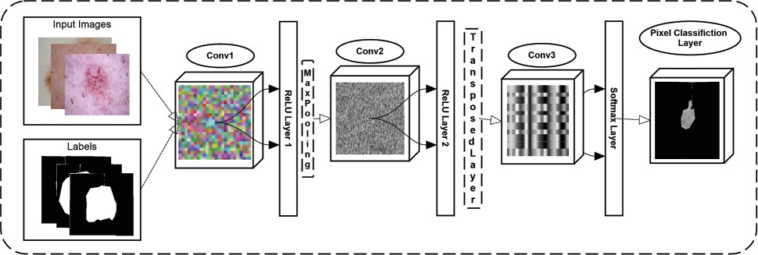After applying CNN to testing data, some noise had to be removed before moving on to the lesion class. We use component labeling operations to remove them where noise has less connected components than lesion area. In the proposed study, an area selection threshold greater than 50 value removes all noise from the images and makes the lesion a final segmented component. I = max(|xi − xj|, |yi − yj| (2) The binary image considers I, x, and y as digital lattice coordinates, then the 8-connectedness of pair of pixels leads to specific metrics that can be used to find objects based on shape or size. These calculations are shown in Eq. (2) [27].

**Fig 2.6: Proposed CNN architect for skin lesion segmentation**

**2.6.4 Feature Extraction**

After the segmentation process, skin lesions’ features are extracted and used to overcome the problem of misclassification. Different types of features, such as the ABCD rule, GLCM features, and in-depth learning-based features are extracted from segmented images. Principal component analysis (PCA) is used to get gray co-matrix to calculate GLCM features. The explanation of these mentioned features is defined below.

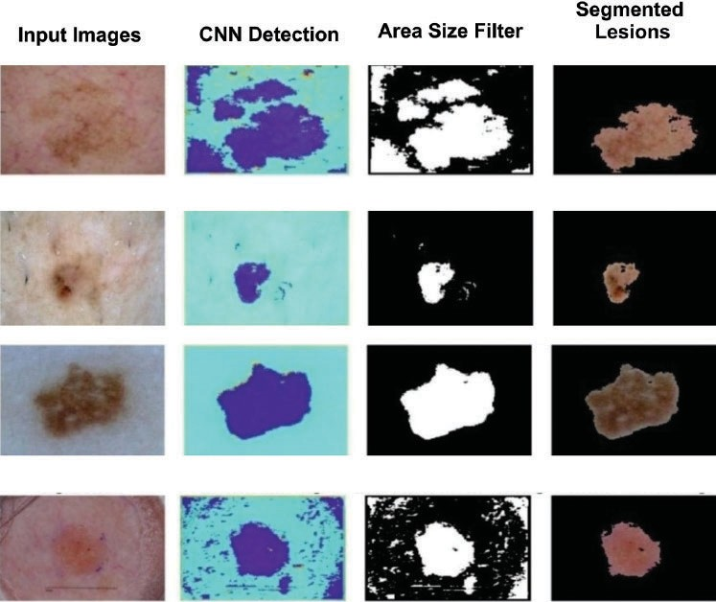

**Fig 2.7: Proposed framework segmentation results**

**2.6.5 Size Filter**

After applying CNN to testing data, some noise had to be removed before moving on to the lesion class. We use component labeling operations to remove them where noise has less connected components than lesion area. In the proposed study, an area selection threshold greater than 50 value removes all noise from the images and makes the lesion a final segmented component.

I = max(|xi − xj|, |yi − yj| (2)

The binary image considers I, x, and y as digital lattice coordinates, then the 8-connectedness of pair of pixels leads to specific metrics that can be used to find objects based on shape or size. These calculations are shown in Eq. (2) [27].

**2.5.6 Feature Extraction**

After the segmentation process, skin lesions’ features are extracted and used to overcome the problem of misclassification. Different types of features, such as the ABCD rule, GLCM features, and in-depth learning-based features are extracted from segmented images. Principal component analysis (PCA) is used to get gray co-matrix to calculate GLCM features. The explanation of these mentioned features is defined below.

**2.6.7 ABCD Rule**

One of the most commonly used methods for accurate skin lesion detection is ABCD (asym- metry, border, color, diameter) parameters. Because these multi-class do not classify uniquely, the collected images have similarities, which is why the ABCD rule is used in the proposed approach and provides good classification accuracy. The acronym of ABCD categorizes clinical and morphological features of skin lesions or mole. The “symmetry” feature used lesion images, which are not symmetric, with the images’ principal x–y and lesion axes aligned (if there is any asymmetry) on the images of significant axes. An irregular border is a notched, ragged, or blurred edge of skin lesion image. The border is translating with peaks in the function, which shows the irregularity of the border.

The color feature indicates various colors in collected images such as white, blue, black, brown, red, etc. The diameter feature described the size of the lesion in a particular image, and each target disease diameter is different.

**2.6.8 GLCM Feature**s

After ABCD feature extraction, different statistical parameters such as Correlation, Homo- geneity, Contrast, Energy are computed.

Statistical analysis is used for skin lesion detection analysis. The PCA algorithm is used to extract these types of features. To obtain statistical parameters, images are converted to grey level. By creating GLCM and its features; statistical measures are extracted [28]. Statistics measures provide information about the texture of the image. Detailed information about statistical features is given below.

Homogeneity This feature shows the Regularity of the calculated region because it computes the distribution of elements in the GLCM to the GLCM diagonal. The following Eq. (3) is used to calculate homogeneity.

Homogeneity = Σ p(i, j) (3)

Energy Energy feature is used to calculate uniformity for different images. It is also known as the angular second moment or uniformity of the image. The constant energy of an image is defined as 1 because its range starts from 0 to 1 .

Energy = p(i, j)2 (6)

Contrast Contrast is used to show the difference in brightness and color of the selected lesion’s object. It can be calculated using the following formula as shown in Eq. (6)

**2.6.9 Deep Features**

The AlexNet algorithm is used to perform deep feature extraction on images [29]. For this process, the images were resized to 227 227 3. The workspace is loaded with the pre-trained model, and a fully connected layer named “fc7” is used for transfer learning. Activations were performed on training and testing images using “fc7” layer. A total of 4363 images were activated, with 3053 images (70%) used for training and 1310 images (30%) used for testing, which creates vectors of size 4096.

**3. DESIGN**

**3.1 INTRODUCTION**

Skin diseases affect a significant percentage of the global population, and timely and accurate diagnosis is crucial for effective treatment. Traditional diagnosis methods rely on the visual inspection of skin lesions by dermatologists, which can be time-consuming and often requires specialized expertise. To overcome these limitations, machine learning models can be used to automatically detect skin diseases from images, providing fast and accurate diagnosis. Machine learning models for skin disease detection use image classification algorithms to analyze skin images and identify potential diseases. These models can be trained on large datasets of labeled skin images to learn patterns and features that are characteristic of different skin diseases. Once trained, the model can be deployed in web or mobile applications, allowing users to upload images of their skin and receive a diagnosis.

The development of accurate and reliable machine learning models for skin disease detection has the potential to revolutionize the field of dermatology, providing faster and more accessible diagnoses for patients. It is important to note that the success of these models depends heavily on the quality and diversity of the dataset used for training, as well as the choice of appropriate machine learning algorithms and model hyperparameters. With careful design and implementation, machine learning models can provide a valuable tool for improving the diagnosis and treatment of skin diseases.

Design for skin disease detection in machine learning .Designing a machine learning model for skin disease detection requires careful consideration of the following steps:

**Data collection:** Gather a large and diverse dataset of skin images that include both normal and diseased skin. These images should be labeled with the corresponding disease diagnosis.

**Data preprocessing:** Clean and preprocess the dataset, removing any duplicate images or low-quality images that may negatively impact the performance of the model. This step may also include resizing and normalization of the images.

**Feature extraction:** Extract relevant features from the preprocessed images that can be used to differentiate between normal and diseased skin. This may include texture, color, and shape features.

**Model selection:** Choose an appropriate machine learning algorithm that can accurately classify the skin images based on their features. Popular algorithms for image classification include Convolutional Neural Networks (CNNs) and Support Vector Machines (SVMs).

**Model training:** Train the chosen machine learning algorithm using the preprocessed and labeled dataset. This step involves splitting the dataset into training and testing sets and tuning the model hyperparameters to achieve the best performance.

**Model evaluation:** Evaluate the performance of the trained model using a separate validation dataset. This step includes measuring the model's accuracy, precision, recall, F1-score, and Receiver Operating Characteristic (ROC) curve.

**Deployment:** Deploy the trained model to a web or mobile application, allowing users to upload their skin images and receive a diagnosis of the detected disease.

It is essential to note that the success of a machine learning model for skin disease detection heavily depends on the quality and diversity of the dataset used for training. Therefore, it is crucial to ensure that the collected dataset is representative of the population that the model is intended to serve.

**3.2 DFD/UML DIAGRAMS**

**3.2.1 DFD Diagrams**

A data flow diagram is graphical tool used to describe and analyze movement of data through a system. These are the central tool and the basis from which the other components are developed. The transformation of data from input to output, through processed, may be described logically and independently of physical components associated with the system. These are known as the logical data flow diagrams. The physical data flow diagrams show the actual implements and movement of data between people, departments and workstations. A full description of a system actually consists of a set of data flow diagrams.

Using two familiar notations Yourdon, Gane and Sarson notation develops the data flow diagrams. Each component in a DFD is labeled with a descriptive name. Process is of DFD’S is done in several levels.

Each process in lower level diagrams can be broken down into a more detailed DFD in the next level. The lop-level diagram is often called context diagram. It consists a single process bit, which plays vital role in studying the current system. The process in the context level diagram is exploded into other process at the first level DFD.

The idea behind the explosion of a process into more process is that understanding at one level of detail is exploded into greater detail at the next level. This is done until further explosion is necessary and an adequate amount of detail is described for analyst to understand the process.

**DFD SYMBOLS**: In the DFD, there are four symbols

* A square defines a source(originator) or destination of system data.
* An arrow identifies data flow. It is the pipeline through which the information flows.
* A circle or a bubble represents a process that transforms incoming data flow into outgoing data flows.
* An open rectangle is a data store, data at rest or a temporary repository of data.

Process that transforms Data

Source Destination of data, Entity (Physical or Logical)

Data flow

**Fig 3.1: DFD Symbols**

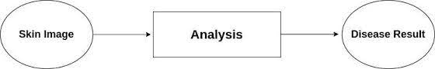**Level 0:**

**Fig 3.2: Level-0 DFD**

The context diagram is an alternative name for the **Face Recognition System DFD Level 0.** Users, the main process, and data flow make up its parts. Also, the project concept is demonstrated using the single process visualization. DFD Level 0 shows the entities that interact with a system and defines the border between the system and its environment. This diagram also depicts the image processing system at a high level. The illustration presents the main process in a single node to introduce the project context. This context explains how the project works in just one look. The skinimage feeds data into the system and then receives the output from it. In addition to this, you will perceive through the diagram that there is already the presence of data flow. Though the process is very general, the flow of data is clear. Nevertheless, just modify this diagram to meet the other requirements and include other matters regarding image processing management.

**Level 1:**

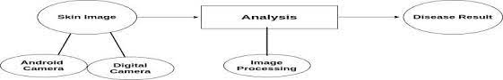

**Fig 3.3: Level-1 DFD**

The “detonated view” of the context diagram is **Image Processing System DFD Level 1**. Its function is to deepen the concept derive from the context diagram. Specifically, level 1 shows the broader details of Image Processing System DFD Level 0. This is to clarify the paths (flow) of data and its transformation from input to output.

**3.2.2 UML Diagrams**

UML is a modeling language used in object oriented software design. UML provides capabilities to specify and visualize the components that make up a software system. UML diagrams mainly represent the structural view and the behavioral view of a system. Structural view of the system is represented using diagrams like class diagrams, composite structure diagrams, etc. Dynamic view of the system is represented using diagrams such as sequence diagrams, activity diagrams, etc. UML version 2.2 includes fourteen diagrams, which includes seven diagrams for representing the structural view and other seven representing the behavioral view. Among the seven behavioral diagrams, four diagrams can be used to represent interactions with the system. There are tools that can be used for UML modeling such as IBM Rational Rose.

3.2.2.1 Use Case Diagram

In UML, use-case diagrams model the behavior of a system and help to capture the requirements of the system. Use-case diagrams describe the high-level functions and scope of a system. These diagrams also identify the interactions between the system and its actors. The use cases and actors in use-case diagrams describe what the system does and how the actors use it, but not how the system operates internally. Use-case diagrams illustrate and define the context and requirements of either an entire system or the important parts of the system. You can model a complex system with a single use-case diagram, or create many use-case diagrams to model the components of the system. You would typically develop use-case diagrams in the early phases of a project and refer to them throughout the development process. Use cases are represented with a labeled oval shape. Stick figures represent actors in the process, and the actor's participation in the system is modeled with a line between the actor and use case. To depict the system boundary, draw a box around the use case itself. UML Use case diagrams are ideal for:

* + - * Representing the goals of system-user interactions.
      * Defining and organizing functional requirements in a system.
      * Specifying the context and requirements of a system.
      * Modelling basic flow of events in a use case.

An effective use case diagram can help your team discuss and represent:

* Scenarios in which your system or application interacts with people, organizations, or external systems.
* Goals that your system or application helps those entities (known as actors) achieve.
* 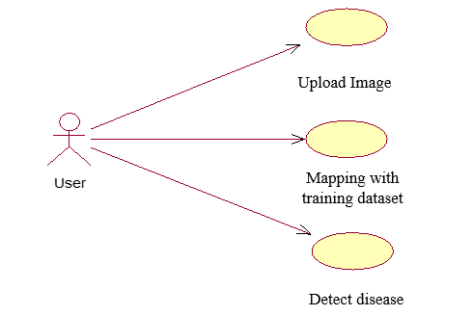The scope of your system.

**Fig 3.4: Use Case Diagram**

3.2.2.2 Sequence Diagram

A sequence diagram is a type of interaction diagram because it describes how and in what order a group of objects works together. These diagrams are used by software developers and business professionals to understand requirements for a new system or to document an existing process. Sequence diagrams are sometimes known as event diagrams or event scenarios. Sequence diagrams can be useful references for businesses and other organizations. Try drawing a sequence diagram to:

* + Represent the details of a UML use case.
  + Model the logic of a sophisticated procedure, function, or operation.
  + See how objects and components interact with each other to complete a process.
  + Plan and understand the detailed functionality of an existing or future scenario.

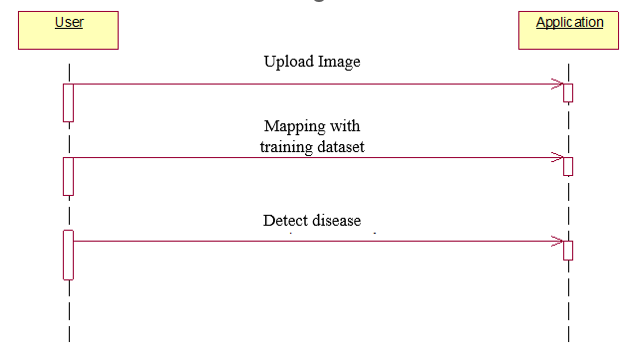

**Fig 3.5: Sequence diagram**

3.2.2.3 Activity Diagram

An activity diagram is a behavioural diagram i.e. it depicts the behaviour of a system. Activity diagram is basically a flowchart to represent the flow from one activity to another activity. The activity can be described as an operation of the system. The control flow is drawn from one operation to another. This flow can be sequential, branched, or concurrent. Activity diagrams deal with all type of flow control by using different elements such as fork, join, etc. The basic purposes of activity diagrams is similar to other four diagrams. It captures the dynamic behaviour of the system. Other four diagrams are used to show the message flow from one object to another but activity diagram is used to show message flow from one activity to another. Activity is a particular operation of the system. Activity diagrams are not only used for visualizing the dynamic nature of a system, but they are also used to construct the executable system by using forward and reverse engineering techniques. The only missing thing in the activity diagram is the message part. It does not show any message flow from one activity to another. Activity diagram is sometimes considered as the flowchart. Although the diagrams look like a flowchart, they are not. It shows different flows such as parallel, branched, concurrent, and single. An activity diagram portrays the control flow from a start point to a finish point showing the various decision paths that exist while the activity is being executed. The purpose of an activity diagram can be described as –

* + - * Draw the activity flow of a system.
      * Describe the sequence from one activity to another.
      * Describe the parallel, branched and concurrent flow of the system.

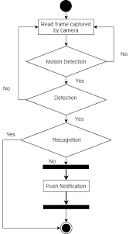

**Fig 3.6: Activity Diagram**

3.2.2.4 Class Diagram

Class diagram is a static diagram. It represents the static view of an application. Class diagram is not only used for visualizing, describing, and documenting different aspects of a system but also for constructing executable code of the software application. Class diagram describes the attributes and operations of a class and also the constraints imposed on the system. The class diagrams are widely used in the modelling of object-oriented systems because they are the only UML diagrams, which can be mapped directly with object-oriented languages. Class diagram shows a collection of classes, interfaces, associations, collaborations, and constraints. It is also known as a structural diagram. The purpose of class diagram is to model the static view of an application. Class diagrams are the only diagrams which can be directly mapped with object-oriented languages and thus widely used at the time of construction. UML diagrams like activity diagram, sequence diagram can only give the sequence flow of the application, however class diagram is a bit different. It is the most popular UML diagram in the coder community. The purpose of the class diagram can be summarized as –

* + Analysis and design of the static view of an application.
  + Describe responsibilities of a system.
  + Base for component and deployment diagrams.
  + 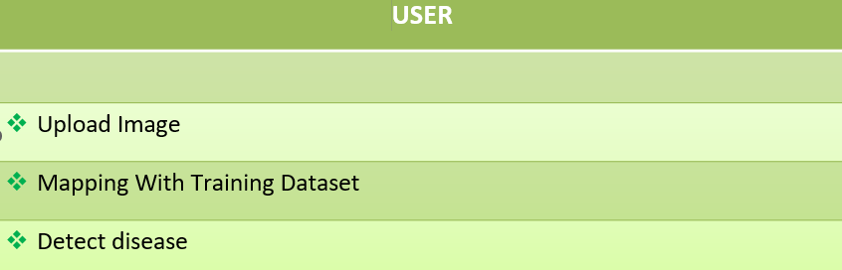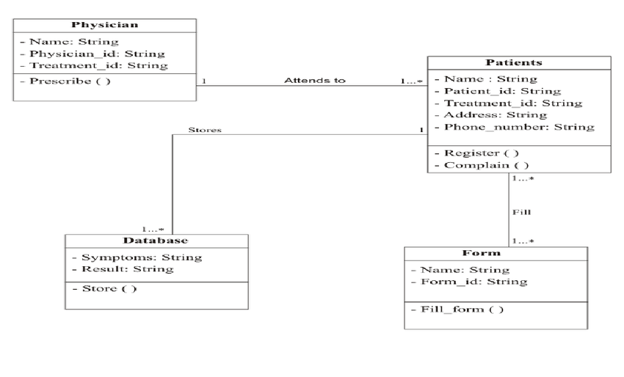Forward and reverse engineering. Class diagram helps construct the code for the software application development.

**Fig 3.7: Class Diagram**

3.2.2.5 Component Diagram

The component diagram for face recognition system is an illustration of how the system components work together to make the system operate correctly. It shows how the software’s parts are organized and how they depend on each other. This diagram also gives a high-level look at the parts of a system. A component diagram in the (UML) Unified Modelling Language shows how parts are wired together to explain the parts of the face recognition system. They are used to show the structure of any kind of system. UML component diagram also portrays the course registration overview that helps the developers to have a better understanding of the exact service behaviour that each component of the software provides.

The UML component diagram shows how image processing comprises a set of deployable components, such as dynamic-link library (DLL) files, executable files, or web services. Using well-defined interfaces, these parts communicate with each other and keep their internal details hidden from each other and the outside world. The Image Processing System UML component diagram explains the sketch of the required software and hardware components and the dependencies between them. These components are labelled to clarify their part in the system’s operation. They were represented by symbols that explain their function and role in the overall image processing system operation.

The component diagram of face recognition system has 8 components which are image scanning, recognition, system database, effected area recording, colour recording, and skin lesion notice for the scanned disease if it is recognized by the system. The colour recording disease information will be gathered by the system from confirmation of activities inside the establishment.

This diagram shows several interfaces that are provided and required. The dependencies on each component are explained through the lines and arrows drawn in the diagram. The required and provided interfaces were declared by the line that has a circle with a semi-circle head. This component diagram shows the structure of image processing, which consists of the software components and their interfaces, user information, and the database. Their dependencies explain how they work together.

You can use component diagrams to show how software systems work at a high level, or you can use them to show how each component works at a lower level, like in a package.

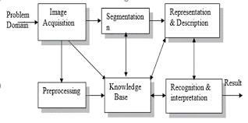

**Fig 3.8: Component Diagram**

**3.3 SOFTWARE DEVELOPMENT LIFE CYCLE-SDLC**

In our project we use waterfall model as our software development cycle because of its step-by-step procedure while implementing.

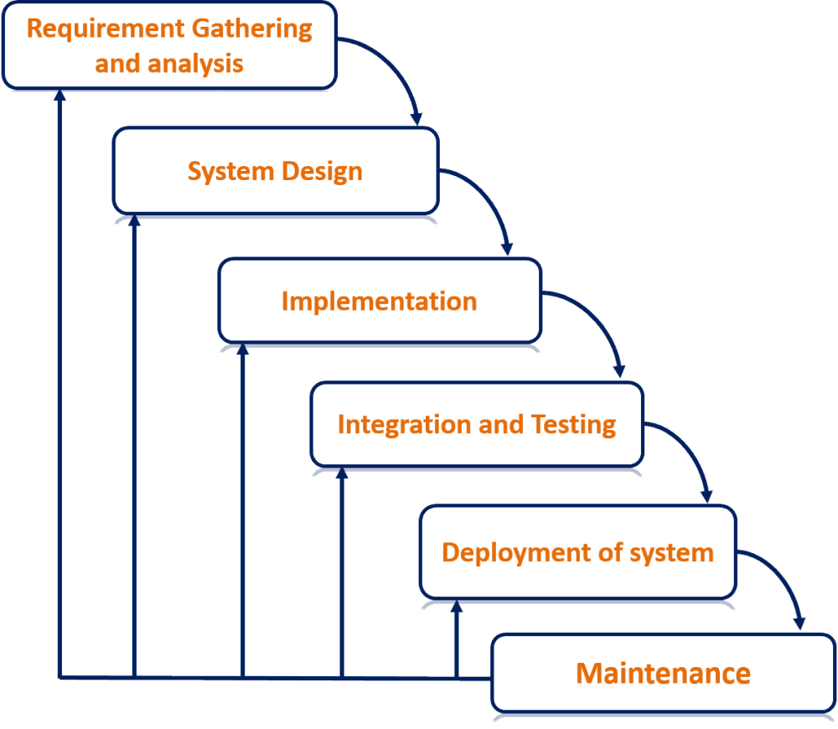

**Fig 3.9: WaterFall Model**

**Requirement Gathering and analysis:** All possible requirements of the system to be developed are captured in this phase and documented in a requirement specification document.

**System Design:** The requirement specifications from the first phase are studied in this phase and the system design is prepared. This system design helps in specifying hardware and system requirements and helps in defining the overall system architecture.

**Implementation:** The inputs from the system design, the system is first developed in small programs called units, which are integrated into the next phase. Each unit is developed and tested for its functionality, which is referred to as Unit Testing.

**Integration and Testing:** All the units developed in the implementation phase are integrated into a system after the testing of each unit. Post integration the entire system is tested for any faults and failures.

**Deployment of system:** Once the functional and non-functional testing is done; the product is deployed in the customer environment or released into the market.

**Maintenance:** There are some issues that come up in the client environment. To fix those issues, patches are released. Also, to enhance the product some better versions are released. Maintenance is done to deliver these changes in the customer environment.

**4. IMPLEMENTATION & DETAILS**

**4.1 INTRODUCTION**

Skin disease prediction is a crucial task in the field of dermatology, as it helps in the early detection and treatment of various skin disorders. With the advancement in machine learning techniques, skin disease prediction can now be automated using various algorithms such as decision trees, support vector machines, random forests, and deep learning techniques like convolutional neural networks (CNNs). The implementation of skin disease prediction can be divided into two main phases: data preparation and model development. In the data preparation phase, a large dataset of images of skin disorders is collected, preprocessed, and augmented to increase the size of the dataset. This process involves various techniques such as image resizing, normalization, and color space transformation to ensure that the images are standardized and can be used by the algorithms.

In the model development phase, the dataset is divided into training, validation, and testing sets, and various machine learning algorithms are used to train the model. The most commonly used algorithm for skin disease prediction is CNNs, as they can automatically learn the features of the skin disorders from the images and can predict the disease with high accuracy. The CNN architecture typically consists of multiple convolutional layers, pooling layers, and fully connected layers, which work together to extract features from the images and classify the skin diseases. After the model is trained, it is tested on the testing set to evaluate its accuracy and performance. The accuracy of the model can be measured using various metrics such as precision, recall, and F1 score. The model can also be evaluated using confusion matrices, which provide a detailed analysis of the performance of the model for each class of skin disease.

In conclusion, skin disease prediction is an important task that can be automated using machine learning algorithms such as CNNs. The implementation of skin disease prediction involves data preparation and model development, and the accuracy of the model can be evaluated using various metrics. This automated process can significantly improve the early detection and treatment of skin disorders, leading to better health outcomes for patients.

**4.1.1 How Does The Skin Disease Prediction Using Machine Learning Classifiers Work?**

Skin disease prediction using machine learning classifiers involves training a model to recognize and classify skin disorders based on images of the skin. The process typically involves several steps:

**Data Collection:** The first step in skin disease prediction is to collect a large dataset of images of skin disorders. This dataset should be diverse and include images of various skin conditions, such as acne, psoriasis, eczema, and skin cancer.

**Data Preprocessing:** Once the dataset is collected, it needs to be preprocessed before it can be used to train the machine learning model. This preprocessing may involve tasks such as resizing, normalization, and color space transformation to ensure that the images are standardized and can be used by the algorithms.

**Feature Extraction:** Next, features are extracted from the preprocessed images. Feature extraction is the process of identifying and selecting the relevant information in the images that can be used to classify skin disorders. This process can be done using various techniques such as convolutional neural networks (CNNs).

**Model Training:** After the features are extracted, a machine learning algorithm is trained on the dataset to learn the relationship between the extracted features and the skin disorders. Various machine learning classifiers such as decision trees, support vector machines, random forests, and deep learning techniques like CNNs can be used to train the model.

**Model Evaluation:** Once the model is trained, it is evaluated using a validation set of images that the model has not seen before. The performance of the model can be evaluated using various metrics such as precision, recall, and F1 score. The model can also be evaluated using confusion matrices, which provide a detailed analysis of the performance of the model for each class of skin disease.

**Prediction:** Once the model is trained and evaluated, it can be used to predict the presence of skin disorders in new images. The model takes in an image of the skin as input and outputs the probability of the presence of each skin disorder. The skin disorder with the highest probability is predicted to be present in the image.

In conclusion, skin disease prediction using machine learning classifiers involves collecting a large dataset of images, preprocessing the data, extracting relevant features, training the model, evaluating its performance, and making predictions based on new images. This process can significantly improve the early detection and treatment of skin disorders, leading to better health outcomes for patients.

**4.2 EXPLANATION OF KEY FEATURES**

In skin disease prediction, the key features that are extracted from images of the skin are crucial for accurately identifying and classifying skin disorders. These features are often extracted using advanced machine learning techniques, such as convolutional neural networks (CNNs), which are designed to automatically learn and extract the most relevant features from the images.

Some of the key features that are commonly used for skin disease prediction include texture, color, shape, size, distribution, and contextual information. Texture provides information about the patterns, fine details, and irregularities in the skin's surface. Color can indicate the presence of characteristic color patterns in different skin disorders. Shape can be an important indicator, as melanomas tend to have irregular shapes, while benign moles tend to be round and symmetrical. Size can also provide valuable information, with different skin disorders producing lesions of different sizes. The distribution of skin lesions can be a crucial feature in skin disease prediction, as some skin disorders tend to affect specific areas of the skin, while others can affect multiple areas of the body. Additionally, contextual information, such as the patient's age, gender, medical history, and lifestyle factors, can provide valuable insights for skin disease prediction.

By extracting and analyzing these key features, machine learning models can be trained to accurately identify and classify different skin disorders. This can help to improve the early detection and treatment of skin disorders, leading to better health outcomes for patients.

Some of the key features that are commonly used for skin disease prediction include:

**Texture:** Texture is a critical feature for skin disease prediction, as it provides information about the patterns, fine details, and irregularities in the skin's surface. For example, skin lesions caused by skin cancer tend to have a rough and scaly texture, while psoriasis lesions have a distinct scaling texture.

**Color:** The color of the skin can also be an important feature in skin disease prediction. Different skin disorders may have characteristic color patterns, such as redness in eczema or yellowish-brown scales in seborrheic dermatitis.

**Shape:** The shape of skin lesions can provide valuable information for skin disease prediction. For instance, melanomas tend to have irregular shapes, while benign moles tend to be round and symmetrical.

**Size:** The size of skin lesions can also be a key feature in skin disease prediction. Some skin disorders, such as psoriasis and eczema, tend to produce smaller lesions, while others, such as skin cancer, can produce larger lesions.

**Distribution:** The distribution of skin lesions can also be an important feature in skin disease prediction. Some skin disorders, such as contact dermatitis, tend to affect specific areas of the skin, while others, such as psoriasis, can affect multiple areas of the body.

**Contextual Information:** Contextual information, such as the patient's age, gender, medical history, and lifestyle factors, can also provide valuable insights for skin disease prediction.

**The procedure is as follows:**

1. In this research work with data with attributes are observable and then all of them are floating data. And there’s a decision class/class variable. This data was collected from Kaggle & Github machine learning repository.
2. In this research 70% data use for train model and 30% data use for testing purpose.
3. In the classification report we were able to find out the desired result.
4. In this analysis the result depends on some part of this research. However, which algorithm gives the best true positive, false positive, true negative, and false negative are the best algorithms in this analysis.

**4.3 METHOD OF IMPLEMENTATION**

**4.3.1 The Project is Implemented as a Python**

Python is an interpreted, object-oriented, high-level programming language with dynamic semantics developed by Guido van Rossum. It was originally released in 1991. Designed to be easy as well as fun, the name "Python" is a nod to the British comedy group Monty Python. Python has a reputation as a beginner-friendly language, replacing Java as the most widely used introductory language because it handles much of the complexity for the user, allowing beginners to focus on fully grasping programming concepts rather than minute details.

Python is used for server-side web development, software development, mathematics, and system scripting, and is popular for Rapid Application Development and as a scripting or glue language to tie existing components because of its high-level, built-in data structures, dynamic typing, and dynamic binding. Program maintenance costs are reduced with Python due to the easily learned syntax and emphasis on readability. Additionally, Python's support of modules and packages facilitates modular programs and the reuse of code. Python is an open-source community language, so numerous independent programmers are continually building libraries and functionality for it.

**Python Use Cases**

* Creating web applications on a server
* Building workflows that can be used in conjunction with software
* Connecting to database systems
* Reading and modifying files
* Performing complex mathematics
* Processing big data
* Fast prototyping
* Developing production-ready software

Professionally, Python is great for backend web development, data analysis, artificial intelligence, and scientific computing. Developers also use Python to build productivity tools, games, and desktop apps.

**Features and Benefits of Python**

* Compatible with a variety of platforms including Windows, Mac, Linux, Raspberry Pi, and others.
* Uses a simple syntax comparable to the English language that lets developers use fewer lines than other programming languages.
* Operates on an interpreter system that allows code to be executed immediately, fast-tracking prototyping.
* Can be handled in a procedural, object-orientated, or functional way.

**Python Syntax**

* Somewhat similar to the English language, with a mathematical influence, Python is built for readability.
* Unlike other languages that use semicolons and/or parentheses to complete a command, Python uses new lines for the same function.
* Defines scope (i.e., loops, functions, classes) by relying upon indentation, using whitespace, rather than braces (aka curly brackets).

**Python Flexibility:**

Python, a dynamically typed language, is especially flexible, eliminating hard rules for building features and offering more problem-solving flexibility with a variety of methods. It also allows uses to compile and run programs right up to a problematic area because it uses run-time type checking rather than compile-time checking.

**4.3.2 Modules**

Implementation is the realization of an application, or execution of plan, idea, model, design, specification, standard, algorithm, or policy. In other words, an implementation is a realization of a technical specification or algorithm as a program, software component, other computer system through programming and deployment. Many implementations may exist for a given specifications or standard.

The language used to implement this project was python and it was very efficient in the execution of this project and the modules used in this project are as follows.

**1.Keras**

Keras is an open-source software library that provides a Python interface for artificial neural networks. Keras acts as an interface for the TensorFlow library. Up until version 2.3, Keras supported multiple backends, including TensorFlow, Microsoft Cognitive Toolkit, Theano.

**2.NumPy**

NumPy is a library for the Python programming language, adding support for large, multi- dimensional arrays and matrices, along with a large collection of high-level mathematical functions to operate on these arrays.

**3.Sequential**

The core idea of Sequential API is simply arranging the Keras layers in a sequential order and so, it is called Sequential API. Most of the ANN also has layers in sequential order and the data flows from one layer to another layer.

**4.TensorFlow**

TensorFlow is a free and open-source software library for machine learning and artificial intelligence. It can be used across a range of tasks but has a particular focus on training and inference of deep neural networks.

**5.Flask**

Flask is a micro web framework written in Python. It is classified as a microframework because it does not require particular tools or libraries. It has no database abstraction layer, form validation, or any other components.

**6.Scimage/Skikit**

Scikit-image, or skimage, is an open source Python package designed for image preprocessing and computer vision.

**7.Gevent**

Gevent is a library based on non-blocking IO Requests(libevent/libev) and lightweight greenlets (essentially Python coroutines).

**4.4 ALGORITHM**

**4.4.1 Convolutional Neural Network**

Convolutional neural networks are one of the most common types of neural networks used in computer vision to recognize objects and patterns in images. One of their defining traits is the use of filters within convolutional layers. Neural networks are artificial systems that were inspired by biological neural networks. These systems learn to perform tasks by being exposed to various datasets and examples without any task specific rules. The idea is that the system generates identifying characteristics from the data they have been passed without being programmed with a pre-programmed understanding of these datasets. Neural networks are based on computational models for threshold logic. Threshold logic is a combination of algorithms and mathematics. Neural networks are based either on the study of the brain or on the application of neural networks to artificial intelligence. The work has led to improvements in finite automata theory. Components of a typical neural network involve neurons, connections, weights, biases, propagation function, and a learning rule. Neurons will receive an input from predecessor neurons that have an activation, threshold, an activation function f, and an output function. Connections consist of connections, weights and biases which rules how neuron transfers output to neuron. Propagation computes the input and outputs the output and sums the predecessor neurons function with the weight. The learning rule modifies the weights and thresholds of the variables in the network.

Within a convolutional layer, the input is transformed before being passed to the next layer. A CNN transforms the data by using filters.

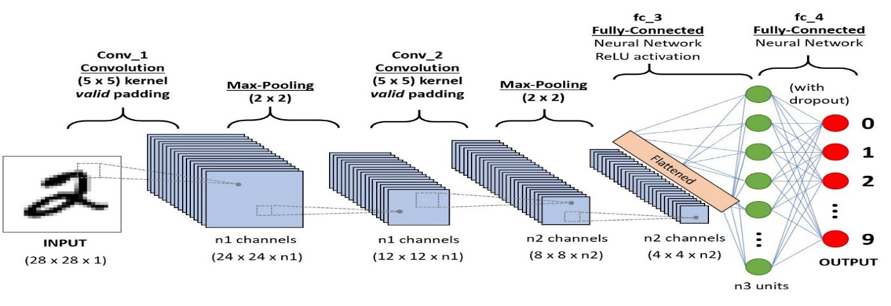

**Fig 4.1: Convolutional Neural Network**

**4.4.1.1 Evolution of Neural Networks**

Hebbian learning deals with neural plasticity. Hebbian learning is unsupervised and deals with long term potentiation. Hebbian learning deals with pattern recognition and exclusive-or circuits; deals with if-then rule. Back propagation solved the exclusive-or issue that Hebbian learning could not handle. This also allowed for multi-layer networks to be feasible and efficient. If an error was found, the error was solved at each layer by modifying the weights at each node. This led to the development of support vector machines, linear classifiers, and max-pooling. The vanishing gradient problem affects feedforward networks that use back propagation and recurrent neural network. This is known as deep-learning. Hardware-based designs are used for biophysical simulation and neurotrophic computing. They have large scale component analysis and convolution creates new class of neural computing with analog. This also solved backpropagation for many-layered feedforward neural networks. Convolutional networks are used for alternating between convolutional layers and max-pooling layers with connected layers (fully or sparsely connected) with a final classification layer. The learning is done without unsupervised pre-training. Each filter is equivalent to a weights vector that has to be trained. The shift variance has to be guaranteed to dealing with small and large neural networks. This is being resolved in Development Networks.

**4.4.1.2 Supervised vs Unsupervised Learning**

Neural networks learn via supervised learning; Supervised machine learning involves an input variable x and output variable y. The algorithm learns from a training dataset. With each correct answers, algorithms iteratively make predictions on the data. The learning stops when the algorithm reaches an acceptable level of performance. Unsupervised machine learning has input data X and no corresponding output variables. The goal is to model the underlying structure of the data for understanding more about the data. The keywords for supervised machine learning are classification and regression. For unsupervised machine learning, the keywords are clustering and association.

**4.4.1.3 What are Filters in Convolutional Neural Networks?**

A filter in a CNN is simply a matrix of randomized number values like in the diagram below.

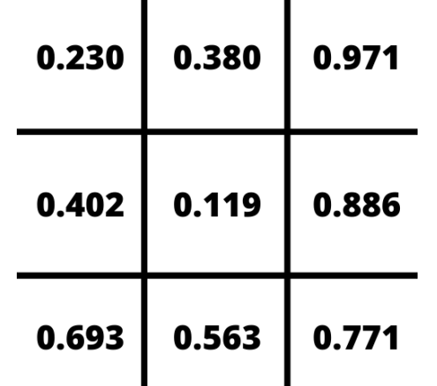

**Fig 4.2: Sample 3 x 3 filter**

The number of rows and columns in the filter can vary and is dependent on the use case and data being processed. Within a convolutional layer, there are a number of filters that move through an image. This process is referred to as convolving. The filter convolves the pixels of the image, changing their values before passing the data on to the next layer in the CNN.

**4.4.1.4 How do Filters Work?**

To understand how filters transform data, let’s take a look at how we can train a CNN to recognize handwritten digits. Below is an enlarged version of a 28x28 pixel image of the number seven from the MNIST dataset.

As the filter convolves through the image, the matrix of values in the filter line up with the pixel values of the image and the dot product of those values is taken. The filter moves, or convolves, through each 3 x 3 matrix of pixels until all the pixels have been covered. The dot product of each calculation is then used as input for the next layer. Initially, the values in the filter are randomized.

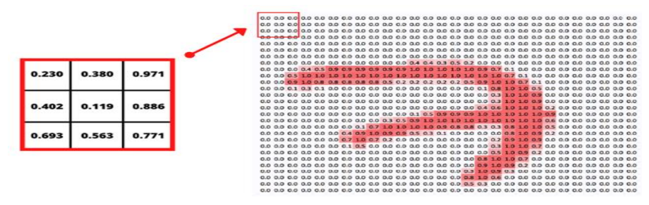

**Fig 4.3: Applying the filter**

As a result, the first passes or convolutions act as a training phase and the initial output isn’t very useful. After each iteration, the CNN adjusts these values automatically using a loss function. As the training progresses, the CNN continuously adjusts the filters. By adjusting these filters, it is able to distinguish edges, curves, textures, and more patterns and features of the image. While this is an amazing feat, in order to implement loss functions, a CNN needs to be given examples of correct output in the form of labelled training data.

**4.4.1.5 CNN-Architecture**

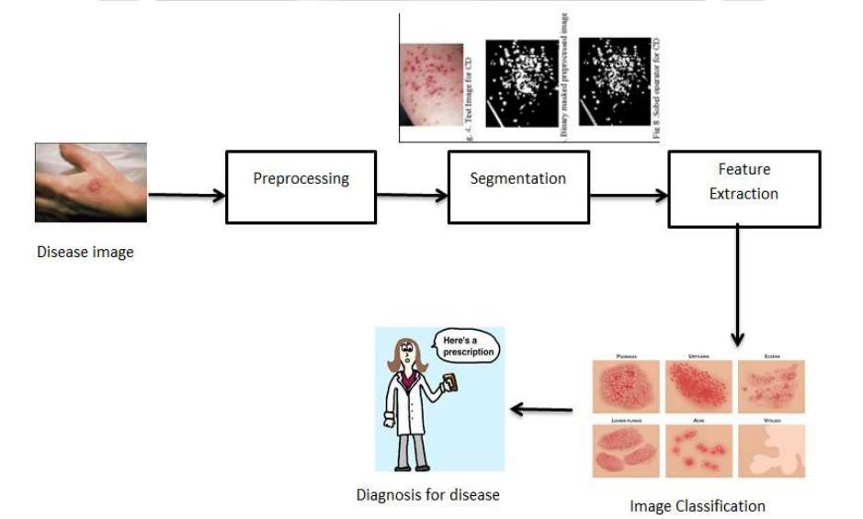The training of deep networks provides with more accurate results, but sometimes it is not satisfied with the availability of few samples and may be in need of more training data. In this work, CNN makes the availability of possible training samples and finally they are aggregated in the training set to create an enlarged training set.

**Fig 4.4: CNN Architecture**

* + - 1. **Defining The CNN Layers**
* **Input Layer:**

The input layer in CNN should contain image data. Image data is represented by a 3-dimensional matrix, as we saw earlier. It would be best if you reshaped it into a single column. For example, suppose you have a picture of dimension 28x28 =784; you need to change it into 784 x 1 before feeding it into an input. If you have "m" training examples, then the input dimension will be (784, m).

* **Convolution Layer:** (Convo + RELU)

The Convo layer is sometimes called the feature extractor layer because the image features are extracted within this layer. First of all, a part of an image is connected to the Convo layer to perform convolution operation as we saw earlier and calculate the dot product between the filter and the receptive field (it is a global part of the input image with the same size as that of filter). The result of the operation is a single integer of the output volume. Then we slide the filter over the following receptive field of the same input image by a Stride, and we repeat the operation again and again. We will continue the same process again and again until we get through the complete picture. Then, the output will be conducted to the input for the next layer. Convo layer contains Rectified Linear Unit activation to make all negative results to zero.

* **Pooling Layer:**

The pooling layer is used to reduce the spatial volume of the input image after convolution. It is used between two convolution layers. If we apply F.C. after the Convo layer without applying max pooling or pooling, the calculation part will be costly, and we don't want it. So, max pooling is the only way to reduce the spatial volume of an input image. In the above example, we have applied max-pooling with a Stride of 2 in a single depth slice. As a result, we can observe the 4X4 dimension input is decreased to 2X2 dimensions. There is no parameter in the pooling layer, but it consists of two primary hyper parameters — Stride(S) and Filter(F). In general, if we have input dimension Width1XHeight1XDepth1, then Width2=(Width1−Filter)/Stride+1 Height2 = (Height1−Filter)/Stride+1 Depth2 = Depth1 Where Height2, Width2, and Depth2 are the height, width, and depth of output.

* **RELU correction layer :**

RELU (Rectified Linear Units) refers to the real non-linear function defined by RELU(x)=max(0,x). Visually, it looks like the following: Fig 5.12- RELU Function Fully.

* **Connected Layer:**

The fully-connected layer is always the last layer of a neural network, convolutional or not — so it is not characteristic of a CNN. This type of layer receives an input vector and produces a new output vector. To do this, it applies a linear combination and then possibly an activation function to the input values received. The last fully-connected layer classifies the image as an input to the network: it returns a vector of size N, where N is the number of classes in our image classification problem. Each element of the vector indicates the probability for the input image to belong to a class. To calculate the probabilities, the fully-connected layer, therefore, multiplies each input element by weight, makes the sum, and then applies an activation function (logistic if N=2, softmax if N>2). This is equivalent to multiplying the input vector by the matrix containing the weights. The fact that each input value is connected with all output values explains the term fully-connected. The convolutional neural network learns weight values in the same way as it learns the convolution layer filters: during the training phase, by backpropagation of the gradient. The fully connected layer determines the relationship between the position of features in the image and a class. Indeed, the input table being the result of the previous layer, it corresponds to a feature map for a given feature: the high values indicate the location (more or less precise depending on the pooling) of this feature in the image. If the location of a feature at a certain point in the image is characteristic of a certain class, then the corresponding value in the table is given significant weight.

* **Output Layer:**

The output layer contains the flag or label, which is of the form one-hot encoded.

**4.5 SAMPLE CODE & OUPUT SCREENS**

**4.5.1 Sample Code**

**4.5.1.1 Admin.py**

from keras.models import Sequential

from keras.layers import Dense

from keras.layers import Convolution2D

from keras.layers import MaxPooling2D

from keras.layers import Flatten

model = Sequential()

model.add(Convolution2D(32,(3,3),input_shape = (64,64,3), activation = 'relu'))

model.add(Convolution2D(32,(3,3),input_shape = (64,64,3), activation = 'relu'))

model.add(MaxPooling2D(pool_size = (2,2)))

model.add(Flatten())

model.summary()

model.add(Dense(128, activation = 'relu'))

model.add(Dense(128, activation = 'relu'))

model.add(Dense(64, activation = 'relu'))

model.add(Dense(64,activation = 'relu'))

model.add(Dense(5,activation = 'softmax'))

from keras.preprocessing.image import ImageDataGenerator

train_datagen = ImageDataGenerator(rescale = 1./255, shear_range = 0.2, zoom_range = 0.2, height_shift_range = 0.2, width_shift_range = 0.2, horizontal_flip = True, vertical_flip = True)

test_datagen = ImageDataGenerator(rescale = 1)

x_train = train_datagen.flow_from_directory(r'D:\Skin-Diseases-Identification-master\Skin Diseases\Skin Diseases\Skin Diseases\train', target_size = (64, 64), batch_size = 32, class_mode = 'categorical')

x_test = test_datagen.flow_from_directory(r'D:\Skin-Diseases-Identification-master\Skin Diseases\Skin Diseases\Skin Diseases\test', target_size = (64, 64), batch_size = 32, class_mode = 'categorical')

x_train.class_indices

model.compile(loss = 'categorical_crossentropy', optimizer = 'adam', metrics = ['accuracy'])

model.fit_generator(x_train, steps_per_epoch =100, epochs = 150, validation_data = x_test, validation_steps = 63)

**4.5.1.2 User.py**

from __future__ import division, print_function

**# coding=utf-8**

import sys

import os

import glob

import numpy as np

from tensorflow.keras.preprocessing import image

from keras.applications.imagenet_utils import preprocess_input, decode_predictions

from keras.models import load_model

from keras import backend

from tensorflow.keras import backend

import tensorflow as tf

global graph

graph=tf.compat.v1.get_default_graph()

from skimage.transform import resize

**# Flask utils**

from flask import Flask, redirect, url_for, request, render_template

from werkzeug.utils import secure_filename

from gevent.pywsgi import WSGIServer

**# Define a flask app**

app = Flask(__name__)

MODEL_PATH = 'Skin_Diseases.h5'

**# Load your trained model**

model = load_model(MODEL_PATH)

@app.route('/', methods=['GET'])

def index():

**# Main page**

return render_template('index.html')

@app.route('/predict', methods=['GET', 'POST'])

def upload():

if request.method == 'POST':

**# Get the file from post request**

f = request.files['file']

**# Save the file to ./uploads**

basepath = os.path.dirname(__file__)

file_path = os.path.join(basepath, 'uploads', secure_filename(f.filename))

f.save(file_path)

img = image.load_img(file_path, target_size=(64, 64))

x = image.img_to_array(img)

x = np.expand_dims(x, axis=

img = image.load_img(file_path, target_size=(64, 64))

x = image.img_to_array(img)

x = np.expand_dims(x, axis=0)

preds = model.predict(x)

x=np.argmax(preds,axis=1)

index = ['Acne', 'Melanoma', 'Psoriasis', 'Rosacea', 'Vitiligo']

text = "Prediction : "+index[int(x)]

return text

if __name__ == '__main__':

app.run(debug=False,threaded = False)

**4.5.2 Output Screens**

* **Screen1:Home Page**

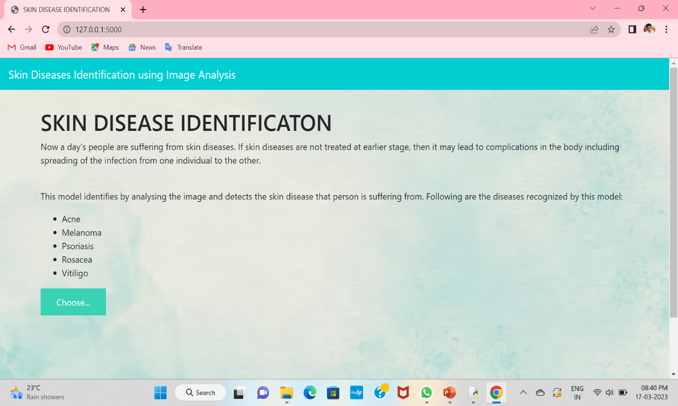This page is Basic Page where we can see the user interaction and input activity and also output acrtivity.

**Screen 4.1: Home Screen**

* **Screen 2: Choosing Image From Acne Dataset**

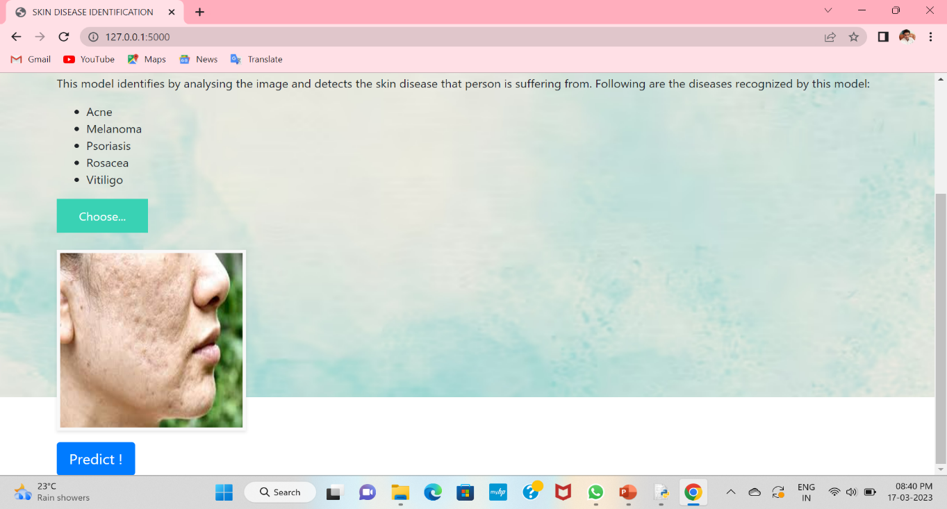Choosing the image from acne dataset among 5 datasets. Then the choosen image Displays here in this format.

**Screen 4.2: Choosing Image From Acne Dataset**

* **Screen 3: Predicting Image As Acne**

By clicking predict button it predicts the acne dataset image as the disease acne, & it shows Result:Prediction:Acne.

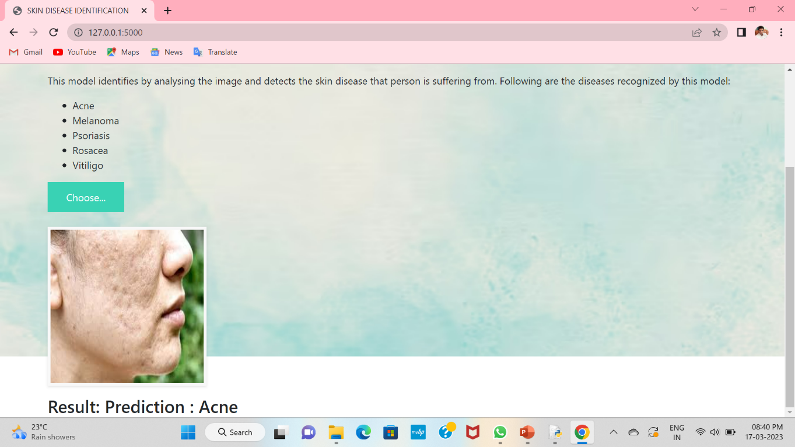

**Screen 4.3: Predicting Image As Acne**

* **Screen 4: Choosing Image From Melanoma Dataset**

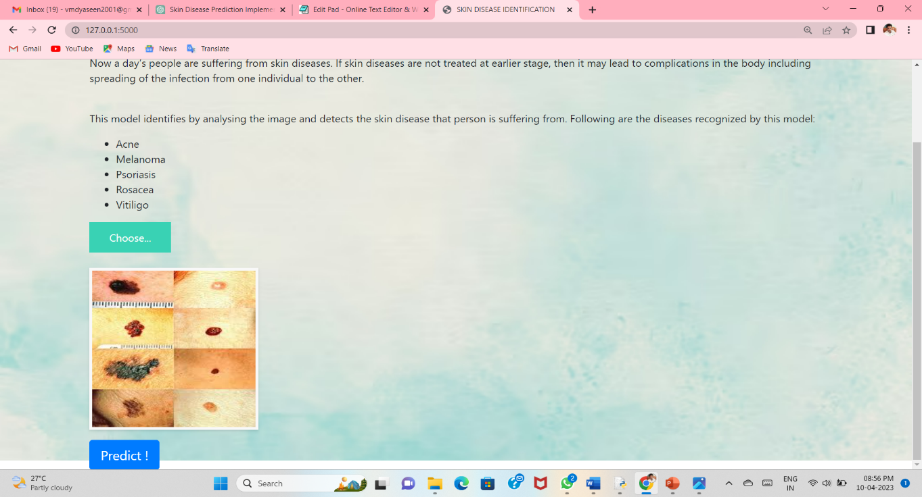Choosing the image from Melanoma dataset among 5 datasets. Then the choosen image Displays here in this format.

**Screen 4.4: Choosing Image From Melanoma Dataset**

* **Screen 5: Predicting Image As Melanoma**

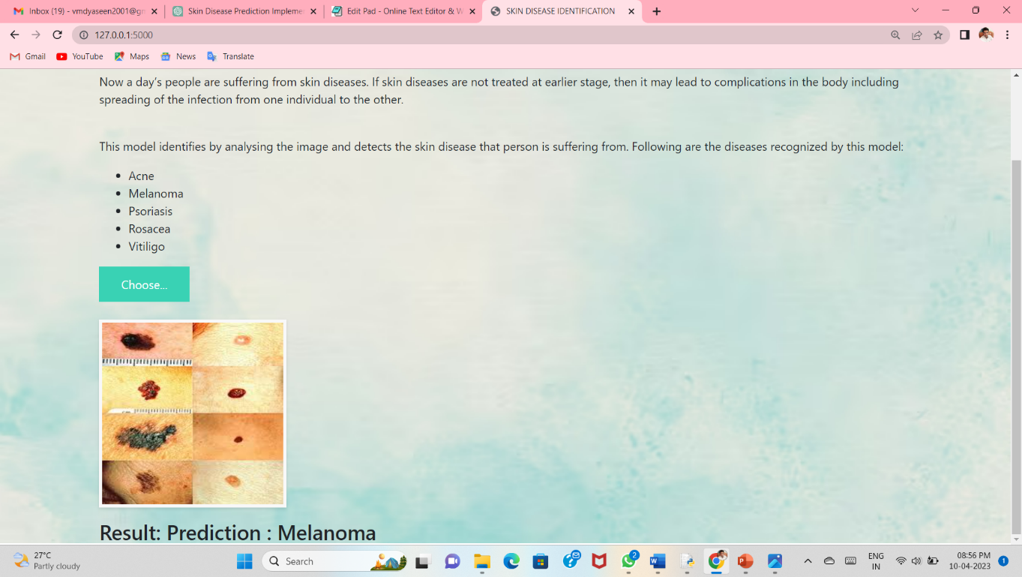By clicking predict button it predicts the Melanoma dataset image as the disease Melanoma, & it shows Result:Prediction:Melanoma.

**Screen 4.5: Predicting Image As Melanoma**

* **Screen 6: Choosing Image From** **Rosacea Dataset**

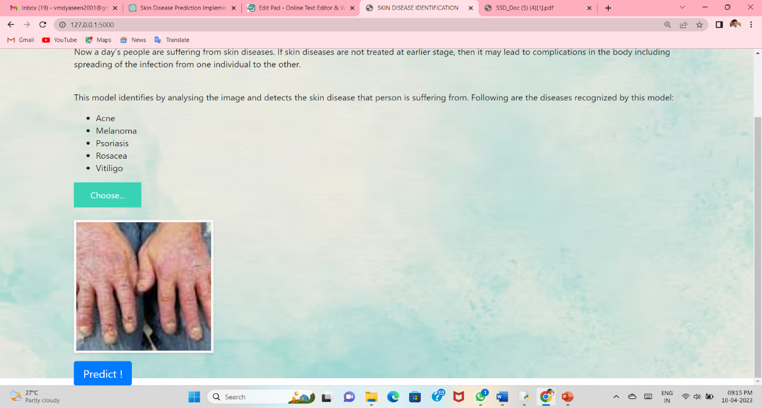Choosing the image from Rosacea dataset among 5 datasets. Then the choosen image Displays here in this format.

**Screen 4.6: Choosing Image From Rosacea Dataset**

* **Screen 7: Predicting Image As Rosacea**

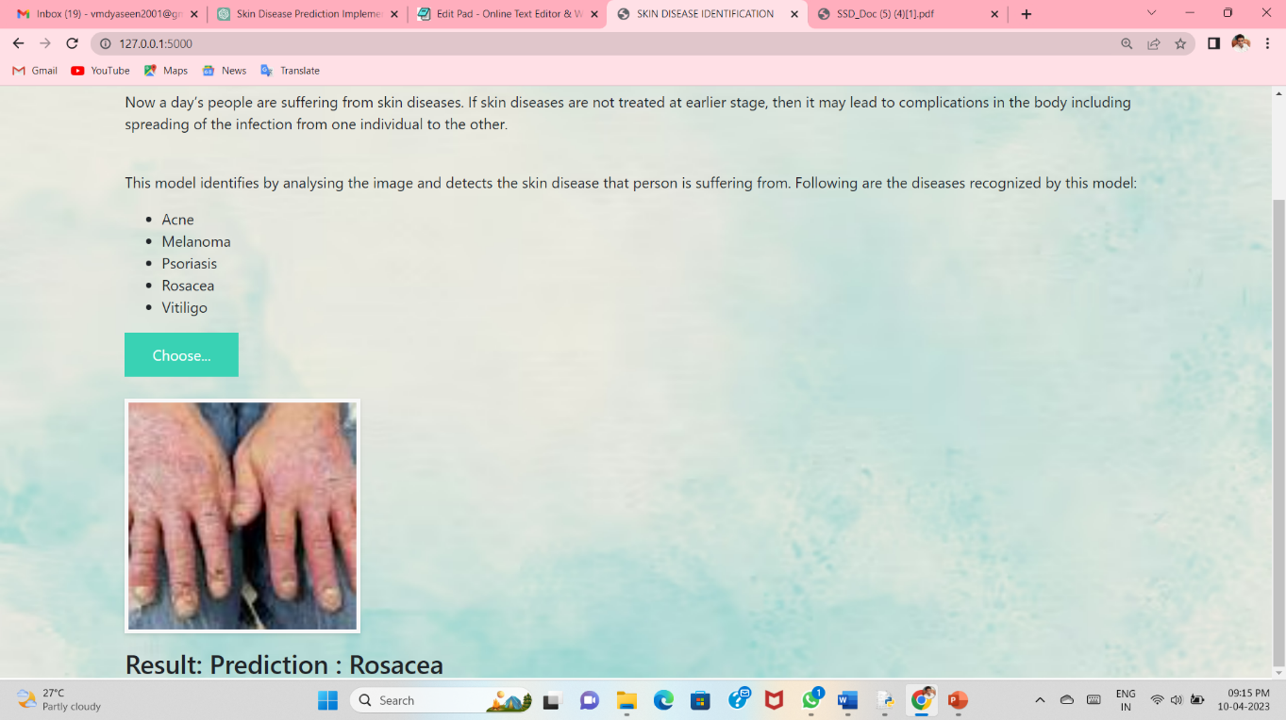By clicking predict button it predicts the Rosacea dataset image as the disease Rosacea, & it shows Result:Prediction:Rosacea.

**Screen 4.7: Predicting Image As Rosacea**

* **Screen 8: Choosing Image From Vitiligo Dataset**

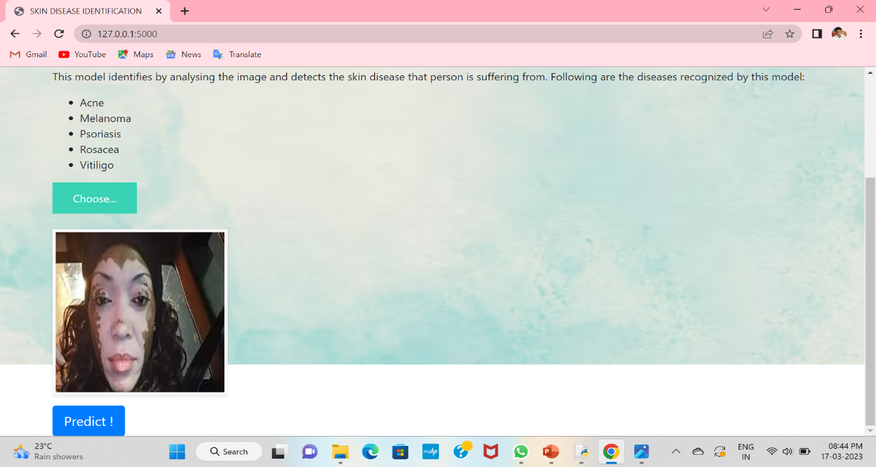Choosing the image from Vitiligo dataset among 5 datasets. Then the choosen image Displays here in this format.

**Screen 4.8: Choosing Image From Vitiligo Dataset**

* **Screen 9: Predicting Image As Vitiligo**

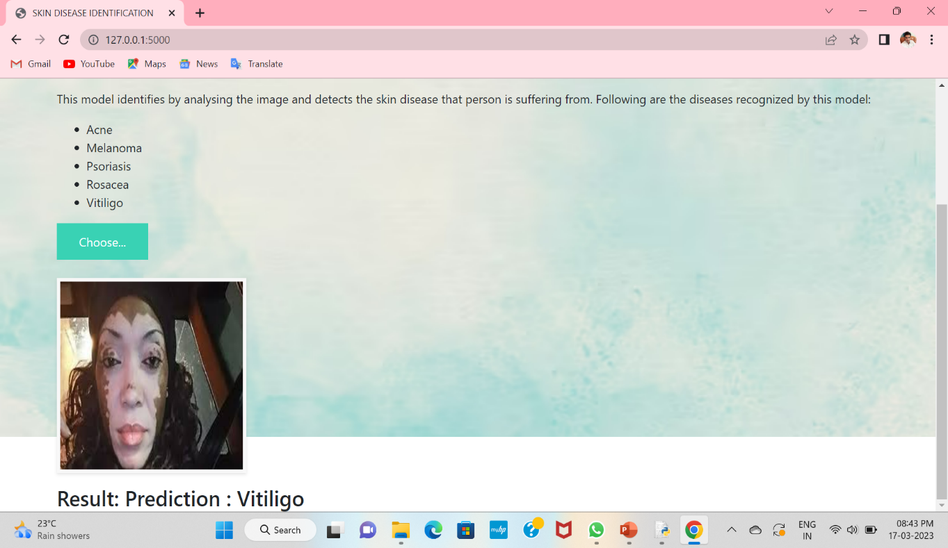By clicking predict button it predicts the Vitiligo dataset image as the disease Vitiligo, & it shows Result:Prediction:Vitiligo.

**Screen 4.9: Predicting Image As Vitiligo**

* **Screen 10: Output Of User.py**

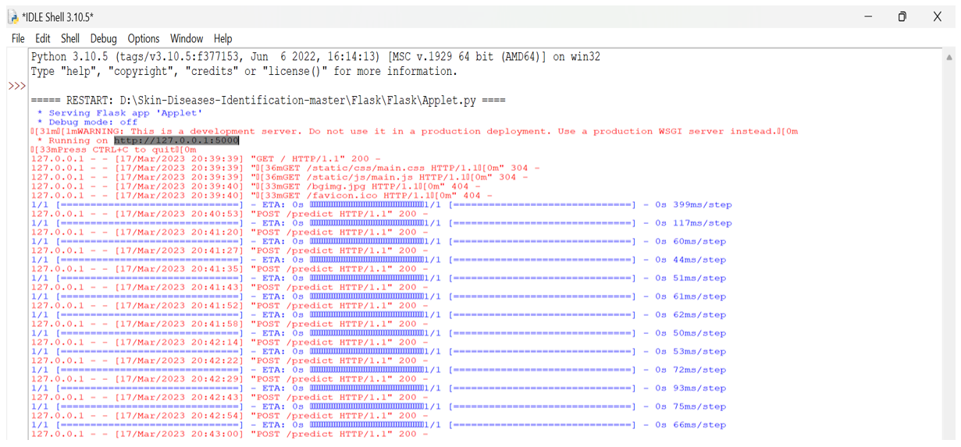Running of User.py code you will get output as shown below in shell prompt of python.

**Screen 4.10: User.py Output**

* **Screen 11: Output Of Admin.py**

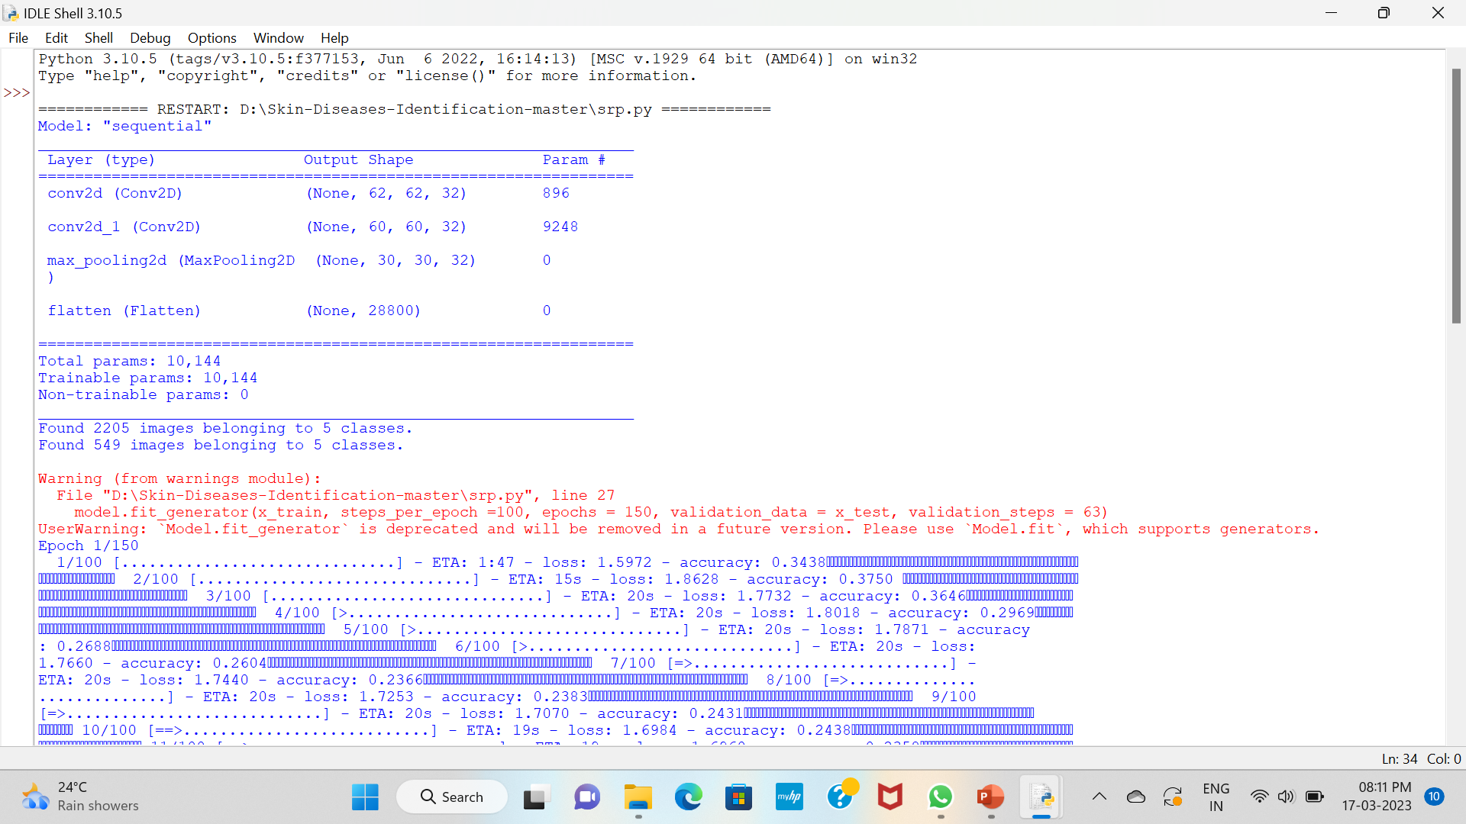 Running of Admin.py code you will get output as shown below in shell prompt of python.

**Screen 4.11: Admin.py Output**

**5. TESTING & VALIDATION**

**5.1 INTRODUCTION**

Software testing is a critical element of software quality assurance and represents the ultimate review of specification, design and coding. It is the major quality measure employed during software development. Testing is the exposure of the system to trial input to see whether it produces correct output. It is a process, which reveals errors in the program. During testing, the program is executed with a set of test cases and the output of the program for the test cases is evaluated to determine if the program is performing as it is expected to perform.

**5.1.1 Testing steps:**

* Validate raw feature data and engineered feature data.
* Debug a ML model to make the model work.
* Implement tests that simplify debugging.
* Optimize a working ML. model.
* Monitor model metrics during development, launch, and production.

There are various types of Testing:

* Unit Testing:

Unit testing is essentially for the verification of the code produced during the coding phase and the goal is test the internal logic of the module/program.

* Integration Testing:

All the tested modules are combined into sub systems, which are then tested. The goal is to see if the modules are properly integrated, and the emphasis being on the testing interfaces between the modules.

* System Testing:

It is mainly used if the software meets its requirements. The reference document for this process is the requirement document.

* Acceptance Testing:

It is performed with realistic data of the client to demonstrate that the software is working satisfactorily.

**5.1.2 Testing Methods:**

Testing is a process of executing a program to find out errors. If testing is conducted 23 successfully, it will uncover all the errors in the software. Any testing can be done basing on two ways:

* White Box Testing:

It is a test case design method that uses the control structures of the procedural design to derive test cases. In this the test cases are generated on the logic of each module by drawing flow graphs of that module and logical decisions are tested on all the cases. Using this testing a Software Engineer can derive the following test cases: Exercise all the logical decisions on either true or false sides. Execute all loops at their boundaries and within their operational boundaries. Exercise the internal data structures to assure their validity. White Box testing attempts to find errors in the following categories:

* Guarantee that all independent paths have been executed.
* Execute all logical decisions on their true and false Sides.
* Execute all loops at their boundaries and within their operational bounds
* Execute internal data structures to ensure their validity.
* Black Box Testing:

It is a test case design method used on the functional requirements of the software. In this strategy some test cases are generated as input conditions that fully execute all functional requirements for the program It will help a software engineer to derive sets of input conditions that will exercise all the functional requirements of the program. Black Box testing attempts to find errors in the following categories:

* Incorrect or missing functions
* Interface errors
* Errors in data structure or external database access
* Performance errors
* Initialization and termination errors

**5.1.3 Testing Approach:**

Testing can be done in two ways:

• Bottom-up approach

• Top-down approach

* Bottom-up Approach:

Testing can be performed starting from smallest and lowest level modules and proceeding one at a time. For each module in bottom up testing a short program executes the module and provides the needed data so that the module is asked to perform the way it will when embedded with in the larger system. When bottom level modules are tested attention turns to those on the next level that use the lower level ones they are tested individually and then linked with the previously examined lower level modules.

* Top-down approach:

This type of testing starts from upper level modules. Since the detailed activities usually performed in the lower level routines are not provided stubs are written. A stub is a module 17 shell called by upper level module and that when reached properly will return a message to the calling module indicating that proper interaction occurred. No attempt is made to verify the correctness of the lower level module.

**5.2 DESIGN OF TEST CASES AND SCENARIOS**

**Test Case: 1**

Input:

Choose the ACNE image from web application.

Output:

Tested for whether the image details predicted are correct or not.

Result:

Success.(Predicted As ACNE)

**Test Case: 2**

Input:

Choose the ACNE image from web application.

Output:

Tested for whether the image details predicted are correct or not.

Result:

Fail.(Predicted As MELANOMA)

**Test Case: 3**

Input:

Choose the ACNE image from web application.

Output:

Tested for whether the image details predicted are correct or not.

Result:

Fail.(Predicted As ROSACEA)

**Test Case: 4**

Input:

Choose the ACNE image from web application.

Output:

Tested for whether the image details predicted are correct or not.

Result:

Fail.(Predicted As VITILIGO)

**Test Case: 5**

Input:

Choose the MELANOMA image from web application.

Output:

Tested for whether the image details predicted are correct or not.

Result:

Success.(Predicted As MELANOMA)

**Test Case: 6**

Input:

Choose the MELANOMA image from web application.

Output:

Tested for whether the image details predicted are correct or not.

Result:

Fail.(Predicted As ACNE)

**Test Case: 7**

Input:

Choose the MELANOMA image from web application.

Output:

Tested for whether the image details predicted are correct or not.

Result:

Fail.(Predicted As ROSACEA)

**Test Case: 8**

Input:

Choose the MELANOMA image from web application.

Output:

Tested for whether the image details predicted are correct or not.

Result:

Fail.(Predicted As VITILIGO)

**Test Case: 9**

Input:

Choose the ROSACEA image from web application.

Output:

Tested for whether the image details predicted are correct or not.

Result:

Success.(Predicted As ROSACEA)

**Test Case: 10**

Input:

Choose the ROSACEA image from web application.

Output:

Tested for whether the image details predicted are correct or not.

Result:

Fail.(Predicted As ACNE)

**Test Case: 11**

Input:

Choose the ROSACEA image from web application.

Output:

Tested for whether the image details predicted are correct or not.

Result:

Fail.(Predicted As MELANOMA)

**Test Case: 12**

Input:

Choose the ROSACEA image from web application.

Output:

Tested for whether the image details predicted are correct or not.

Result:

Fail.(Predicted As VITILIGO)

**Test Case: 13**

Input:

Choose the VITILIGO image from web application.

Output:

Tested for whether the image details predicted are correct or not.

Result:

Success.(Predicted As VITILIGO)

**Test Case: 14**

Input:

Choose the VITILIGO image from web application.

Output:

Tested for whether the image details predicted are correct or not.

Result:

Fail.(Predicted As ACNE)

**Test Case: 15**

Input:

Choose the VITILIGO image from web application.

Output:

Tested for whether the image details predicted are correct or not.

Result:

Fail.(Predicted As MELANOMA)

**Test Case: 16**

Input:

Choose the VITILIGO image from web application.

Output:

Tested for whether the image details predicted are correct or not.

Result:

Fail.(Predicted As ROSACEA)

**5.3 VALIDATION**

The system has been tested and implemented successfully and thus ensured that all the requirements as listed in the software requirements specification are completely fulfilled. In case of erroneous input corresponding error messages are displayed.

**6. CONCLUSION & FUTURE ENHANCEMENT**

**6.1 CONCLUSION**

In conclusion, skin disease prediction is an important area of research that aims to improve early detection and diagnosis of various skin conditions. Machine learning algorithms have shown promising results in this area, with high accuracy rates achieved in predicting skin diseases based on various features such as images, patient history, and genetic data. However, there are still challenges that need to be addressed, such as the need for large and diverse datasets, standardization of data collection and analysis, and ensuring the ethical use of patient data. Further research is needed to refine and optimize machine learning algorithms for skin disease prediction and to ensure that they can be effectively integrated into clinical practice.

Overall, the development of accurate and reliable skin disease prediction models has the potential to significantly improve patient outcomes by enabling earlier detection and more effective treatment of skin conditions.

**6.2 Future Enhancement**

Jason Fried says, “When is your product or service finished? When should you put it out on the market? When is it safe to let people have it? Probably a lot sooner than you are comfortable with. Once your product does what it needs to do, get it out there [10].

Just because you have still got a list of things to do does not mean it is not done. Do not hold everything else up because of a few leftovers. You can do them later. And doing them later may mean doing them better, too. [10]. There are many enhancements and extensions which will be added in the future, first, the method of detect skin disease must be on the mobile application developed, then detection the skin lesion in Dermis layer of the skin, finally must detect all the skin disease in the world and degree of disease.

**7. BIBILOGRAPHY**

1. Arifin, S., Kibria, G., Firoze, A., Amini, A., & Yan, H. (2012) “Dermatological Disease Diagnosis Using Color-Skin Images.” Xian: International Conference on Machine Learning and Cybernetics.
2. Yasir, R., Rahman, A., & Ahmed, N. (2014) “Dermatological Disease Detection using Image Processing and Artificial Neural Network.” Dhaka: International Conference on Electrical and Computer Engineering.
3. Santy, A., & Joseph, R. (2015) “Segmentation Methods for Computer Aided Melanoma Detection.” Global Conference on Communication Technologies.
4. Zeljkovic, V., Druzgalski, C., Bojic-Minic, S., Tameze, C., & Mayorga, P.(2015) “ Supplemental Melanoma Diagnosis for Darker Skin Complexion Gradients.” Pan American Health Care Exchanges
5. Suganya R. (2016) “An Automated Computer Aided Diagnosis of Skin Lesions Detection and Classification for Dermoscopy Images.” International Conference on Recent Trends in Information Technology.
6. Alam, N., Munia, T., Tavakolian, K., Vasefi, V., MacKinnon, N., & Fazel Rezai.R. (2016) “Automatic Detection and Severity Measurement of Eczema Using Image Processing.” IEEE.
7. Kumar, V., Kumar, S., & Saboo, V. (2016) “Dermatological Disease Detection Using Image Processing and Machine Learning.” IEEE.
8. Krizhevsky, A., ILYA, S., & Geoffrey, E. (2012) “ImageNet Classification with Deep Convolutional Neural Networks.” Advances in Neural Information Processing Systems.
9. Cristianini, N., Shawe, J., “Support Vector Machines”,2000.
10. SOMMERVILLE, I., “Software Engineering”. 9th.2011.